|  |
| --- |
| Mid-term evaluation of the Instrument for Financial Support for Border Management and Visa policy for the period 2021-2027  of the  Republic of Bulgaria  Report |
| PMG Analytics Ltd. |
|  |

Contents

Abbreviations 2

Summary 3

1 Introduction 5

1.1 Purpose of the evaluation 5

1.2 Scope of the evaluation 5

1.3 Policy context - border security and visa policy a 6

1.4 Logic of the intervention 11

1.5 Assessment methodology and limitations 14

2 Current status of BMVI 16

2.1 Procedural progress 16

2.2 Financial progress 18

2.3 Physical progress 21

3 Evaluation findings 25

3.1 Relevance 25

3.2 Effectiveness 32

3.3 Efficiency 39

3.4 Coherence and complementarity 45

3.5 EU Added Value 48

4 Conclusions and recommendations 51

4.1 Conclusions 51

4.2 References 52

Annexes 56

Annex 1 Analytical framework 57

Annex 2 Survey of DGPC staff 60

Annex 3 Interviews conducted 66

# Abbreviations

|  |  |
| --- | --- |
| Abbreviation |  |
| AMIF | Asylum, Migration and Integration Fund |
| BMVI | The instrument for financial support for border management and visa policy for the period 2021-2027. |
| CISD | Communication and Information Systems Directorate (MoI) |
| DCM | Decision of the Council of Ministers |
| DGBP | Directorate General "Border Police" (MoI) |
| DGCOC | "General Directorate for Combating Organised Crime" (MoI) |
| DM | Migration Directorate |
| EBCG | The European Border and Coast Guard Agency (EBCGA) and the competent authorities of the Member States (Regulation 2019/1896 |
| EBCGA | European Border and Coast Guard Agency |
| EBF | European Border Fund (2007-2013) |
| EES | EU Entry Exit System |
| (E)IBM | (European) Integrated Border Management |
| Frontex | European Border and Coast Guard Agency |
| IPD | International Projects Directorate (MoI) |
| ISF | Internal Security Fund (2021-2027) |
| ISF-Borders | Internal Security - Borders Fund (2014-2020) |
| ISS | Integrated surveillance system at Bulgarian-Turkish border |
| LCC | Local Coordination Centre of the Border Police |
| MA | Managing Authority (MoI IPD) |
| MFA | Ministry of Foreign Affairs |
| MMIS | Management and Monitoring Information System of European Funds of the Bulgarian Government |
| MoI | Ministry of the Interior |
| NCC | National Coordination Centre (NCC) at the Border Police |
| NSIBM | National Strategy for Integrated Border Management of the Republic of Bulgaria (2020-2025) |
| PPA | Public Procurement Act |
| RCC | Regional Coordination Centre (RCC / Eurosur) |
| SANS | State National Security Agency |
| SAR | State Agency for Refugees |
| SIS | Schengen Information System |
| SO1 | Specific objective 1 (Article 3 of the BMVI Regulation) |
| SO2 | Specific objective 2 (Article 3 of the BMVI Regulation) |
| VIS | Visa Information System |

# Executive Summary

The Instrument for Financial Support for Border Management and Visa Policy (BMVI), as part of the Integrated Border Management Fund, is established by Regulation (EU) 2021/1148 for the period 2021-2027. It includes two specific objectives: Specific Objective 1 (SO1) to support effective European integrated management of external borders and Specific Objective 2 (SO2) to support the common visa policy.

The purpose of this report is to provide a mid-term evaluation of the implementation of the BMVI Programme of the Republic of Bulgaria (the Programme), as provided for in Article 44(5) of Regulation (EU) 2021/1060. The main objective of the mid-term evaluation is to ensure that the regulatory framework and the Programme are appropriate to achieve the specific objectives of Regulation 2021/1148; that the objectives will be achieved in a cost-effective manner; and that the Programme provides appropriate support to address changing needs and adds value to the EU in line with other funding sources.

The present Mid-term Evaluation was carried out between February and March 2024. The data collection methodology included review of Programme, other programming, procedural, and project documents, as well as relevant legislation. Semi-structured in-depth interviews with 27 stakeholders were carried out, and an online survey amongst 278 border guards was also conducted. The key methodological challenges included: (1) the short period to conduct the evaluation (20 calendar days), (2) the early stage of the Programme implementation and ongoing implementation activities while the evaluation was taking place, and (3) the absence of baseline assessment, as the ex-post evaluation of the ISF-Borders (2014-2020) had not started yet.

The procedural and financial progress of the BMVI programme at the time of writing of this report is substantial, given the short time elapsed since the approval of the Programme, and the subsequent approval project proposals in late 2023 and early 2024. The approved BMVI Programme for the period 2021-2027 totals €159 490 672 with national co-financing. Funding from 4 specific actions, totalling €107 175 899 with national funding, has been added to the programme in 2023 period. This brings the total value of the BVMI funds to €266 666 571.

With the adoption in February 2023 of the 2023 Indicative Annual Work Programme for the BMVI, four procedures have been carried out for a total amount of €108 689 819. These procedures included 31 operations covering both specific objectives of the Programme. Only the first procedure (which contained only SO1 related projects) had been completed by the date of the start of work on this report, and the remaining three were completed by March 2024, when the present evaluation was being completed. The beneficiaries of the four procedures launched in 2023 include: the Communication and Information Systems Directorate (CISD) of the of the Ministry of Interior (MoI), the General Directorate of Border Police (DGBP) (MoI), the Bulgarian Identity Documents Directorate (BIDD) of the MoI, as well as the Ministry of Foreign Affairs (MFA).

The period 2019-2023, during which the planning of the BMVI Programme and the first stages of its implementation took place, was characterised by dynamics at national and European level, both in terms of the migration situation and policies to counter irregular migration. The ongoing global conflicts create a constant migratory pressure on the European Union (EU) and Bulgaria, in particular, given the specific geographical location of the country on the external borders of the EU. Over the past decade Bulgaria has been one of the main entry points and transit migratory route towards the Western Balkans and other EU Member States for migration flows originating from Syria, Afghanistan, Iraq and North Africa. It should be added that in the 2021-2023 period, the situation in Bulgaria was marked by significant political instability and the change of six different governments, as well as changes in the leadership of all key BMVI beneficiaries. Finally, Bulgaria’s entry and full application of the Schengen acquis as of March 31, 2024 further changed the dynamics and the needs in respect to border management (e.g. compensatory measures).

Despite these challenges, the Programme is very much responding to the real needs of all relevant stakeholders. The actions included in the Programme, including the 2023 procedures respond to the needs identified both, at the EU level, and at the national level (as identified in the National Strategy on Migration of the Republic of Bulgaria 2021-2025 (under SO2) and the National Strategy for Integrated Border Management of the Republic of Bulgaria 2021-2025 (under SO1)). However, some priority strategic areas are not covered in the Programme, such as risk analysis and compensatory measures. The majority of actions are continuation of similar activities from the previous funding period (2014-2020). The specific objectives set out in the Programme provide a sufficient flexibility, allowing to address all relevant needs.

Due to the early stage of implementation of the projects approved under the BMVI programme, it is too early to assess how effective they are in terms of achieving the objectives and results. Although there are no specific indicator values reported yet, the expectation of the consulted stakeholders is that the final indicator targets will be achieved.

The management and control system is detailed and efficient. Both the Managing Authority and the Beneficiaries consider that the overall indicators reflect the main achievements of the programme and are in line with the intervention logic of the BMVI programme. The beneficiaries have also received sufficient guidance from the Managing Authority (MA) on the content and reporting of the indicators. Beneficiaries expressed their appreciation to the MA for good communication and flexibility.

The Managing Authority has implemented measures to ensure compliance with the horizontal principles set out in the Horizontal Regulation 2021/1060 as well as in national legislation, including compliance with the EU Charter of Fundamental Rights in the implementation of the programme - Article 9(1). The application of the principles of equal opportunities, transparency and equal treatment is monitored by the Managing Authority at all stages of preparation, evaluation and implementation of operations selected for support. While the guidelines and overall support provided by the MA and the European Commission on the horizontal principles has been significant, the stakeholders lack practical experience in the designing of projects, where such principles are mainstreamed or integrated.

The BMVI programme is coherent to with other EU funds (AMIF and ISF) to a large extent, with some synergies with other programmes (notably INTERREG-IPA). Structures, organisational arrangements and coordination mechanisms are in place to ensure coordination, complementarity and, where appropriate, synergies between different management modes of the same programme. The Managing Authority maintains close coordination between the BMVI and the Managing Authorities of programmes funded under Regulation 2021/1060 Funds and the Partnership Agreement in order to maximise the impact of assistance in close and similar thematic areas. The evaluation identified opportunities for further alignment with ISF, and the possible support to criminal investigations activities of DGBP.

Despite the early stages of the programme, some possible shortfalls in respect to the cost-effective and efficient implementation of the Programme were identified. These included: (1) the lack of established long-term vision and multitude of approaches for maintenance and development of the Integrated Surveillance System (ISS) at green borders; (2) need to further align Bulgarian legislation for the implementation of Regulation 2021/1148, and repetitive procedures for the approvement of specific actions under national legislation, and (3) burdensome procedures for timesheets reporting between beneficiaries and the MA.

The activities funded under the BMVI programme support to a great extent the development of European policies in the field of the European integrated border management and visa policy. The programme operations are planned to extend both the scope and the size of the activities in these policies financed by the state budget of the Republic of Bulgaria.

The key recommendations to beneficiaries and the MA include:

* Inclusion in the Programme of other areas of strategic priority, such as risk analysis and compensation measures.
* Beneficiaries to consider further expansion of the communication channels and messages to reach the wider public, including wider use of social media;
* Adopting a policy document outlining a long-term vision for the technical development of the integrated surveillance system at the green border;
* Introducing legislative amendments to the Shared Management of EU Funds Act, to reduce the time for approval of specific actions at national level.

# Introduction

## Purpose of the evaluation

The purpose of this report is to provide an mid-term evaluation of the implementation of the programme of the Republic of Bulgaria under the Instrument for financial support for visa policy management for the period 2021-2027. The evaluation was carried out in accordance with the provision of Article 44(5) of Regulation (EU) 2021/1060 of the European Parliament and of the Council of 24 June 2021.

The main objective of the mid-term evaluation is to ascertain that the regulatory framework and approved programmes under the BMVI are fit for purpose and will provide a contribution to achieving the objectives set at a reasonable cost; appropriate support to address changing needs; and EU added value in line with other funding sources or modalities. One of the objectives of the mid-term evaluation is to make recommendations on how to improve the quality of the content and implementation of the BMVI programme.

For the **BMVI 2021-2027**, the mid-term evaluation assesses the contribution of the BMVI Programme against the following specific objectives of the instrument:

* Specific Objective 1. To support the effective European integrated management of external borders, carried out by the European Border and Coast Guard Agency as a shared responsibility of the European Border and Coast Guard Agency and national authorities responsible for border management, to facilitate legal border crossings, to prevent and detect cases of illegal immigration and cross-border crime and to manage migration flows effectively;
* Specific objective 2: Support the common visa policy to ensure a harmonised approach to issuing visas and facilitating legitimate travel, while helping to prevent migration and security risks.

## Scope of the evaluation

The criteria used in the evaluation of the financial instrument are in line with the Better Regulation Guidelines[1] , and include: relevance, effectiveness, efficiency, coherence/complementarity and EU added value.

The thematic scope of the evaluation includes:

* progress towards achieving the milestones and targets of the implementation framework and the annual reports on the implementation of the country programmes of the Instrument;
* the effectiveness of the management and control system;
* the continued relevance and appropriateness of the implementation measures;
* coordination, coherence and complementarity between actions supported by BMVI and support provided by other Union financial instruments;
* efficiency of resources used to achieve objectives
* the EU added value of actions implemented under the Fund;
* The assessment of actions carried out with, in or in respect of third countries in accordance with Article 13(12) and Article 20.

Figure . Scope of the evaluation

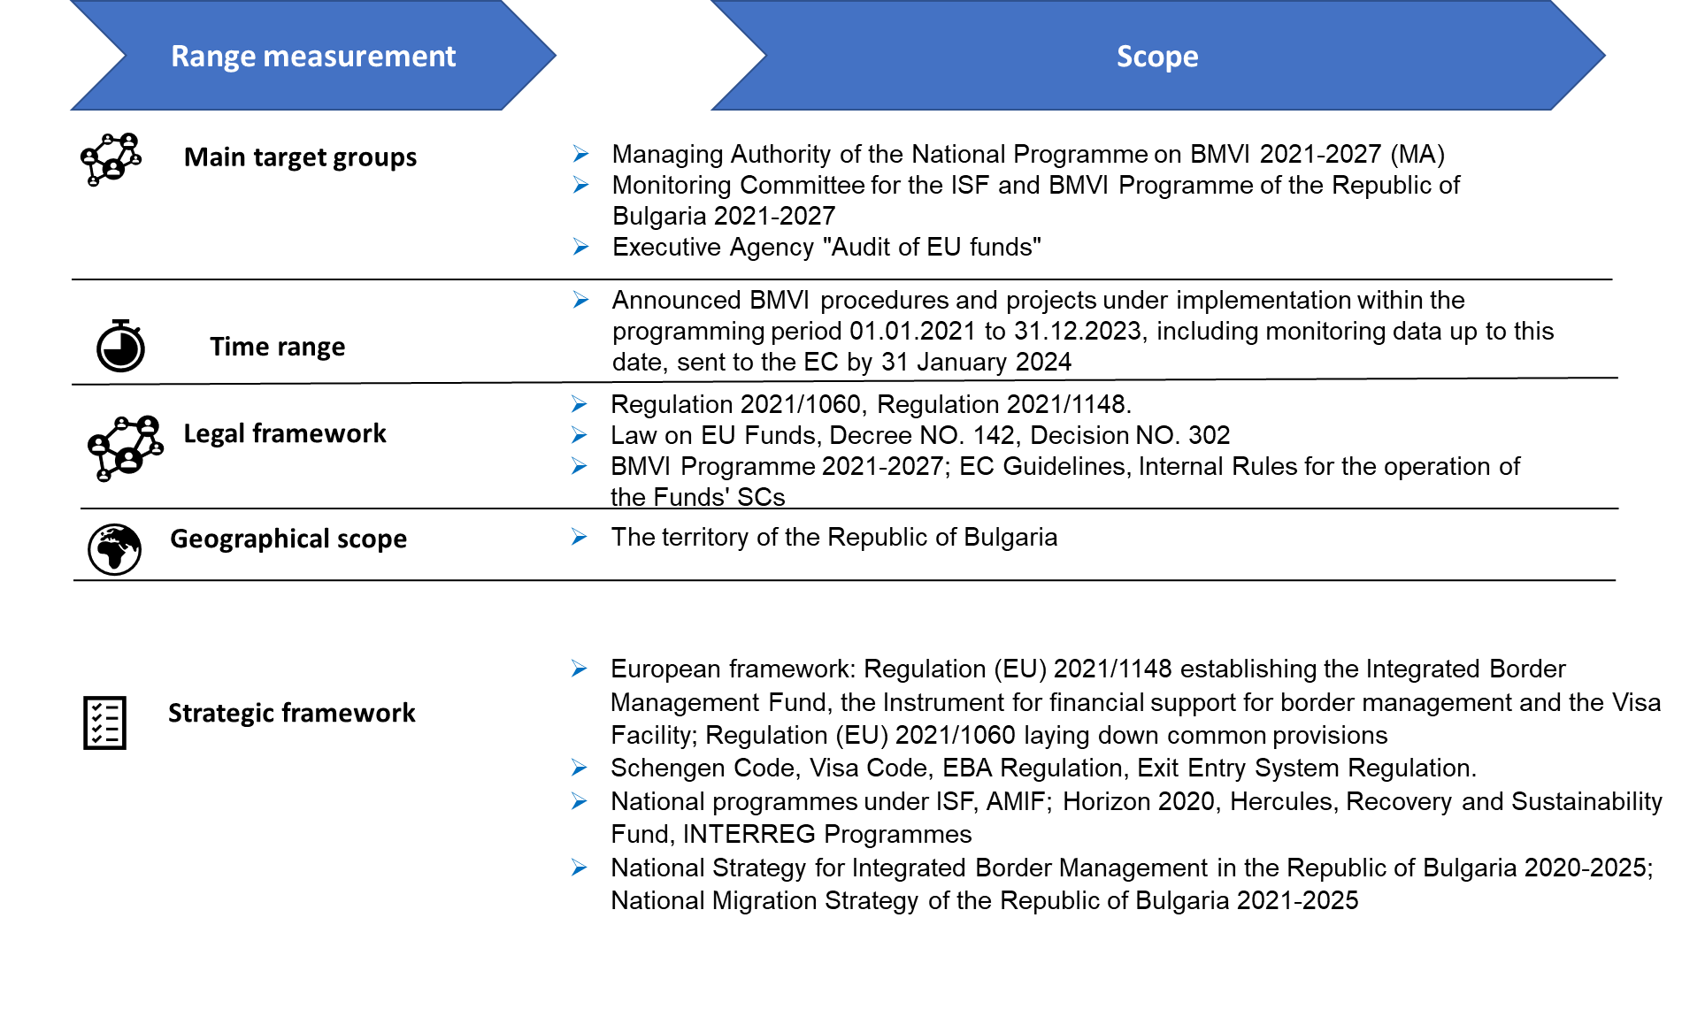

## Policy context - border security and visa policy a

The period 2019-2023, during which the planning of the BMVI Programme as well as its implementation took place, is characterised by dynamics at national and European level, both in terms of the migration situation and policies to counter irregular migration. Three external factors have influenced the migration situation as well as the travel of third-country nationals requiring visas for short stays:

* At the beginning of 2020, with the declaration of pandemic Covid 19, the external European borders were closed. As a result of the restrictive measures globally in the period 2020-2021, illegal migration flows as well as movement across borders in general were severely restricted;
* The Russian invasion of Ukraine in 2022 has led to an increase in the flow of Ukrainian refugees across Bulgarian borders. Between 2022 and 2023, 170 970 Ukrainian nationals have sought temporary protection Bulgaria[2] , although the majority are believed to have returned to Ukraine.
* At the end of 2023, a decision was taken to accept Bulgaria in the Schengen area, with the abolition of border controls at air and sea borders as of 31.3.2024. At the same time, from this date, Bulgaria will be granted full access to the Visa Information System (VIS) and will start issuing 'Schengen visas'.

These events have an impact on the baseline situation (in terms of regular and irregular migration flows), which at the mid-term evaluation stage, January 2024, is very different from the 2021-2022 situation when the BMVI programme was being prepared.

### State of border security and migration flows

With regard to migration flows, as well as the flows of passengers across the borders of Bulgaria - the following trends and events are distinguished, which also have their impact on the work of the competent authorities and needs:

* Since the containment of the migration crisis (2015-2016), irregular migration flows have strongly decreased. At the same time, there has been an increase in travel flows and illegal crossing attempts (see Figure 1, Figure 2)
* After post-COVID 19 gradual opening of the borders in 2021, there followed two years of increasing pressure from irregular migration at the external borders of Bulgaria and the European Union. The year 2023 marked the year with the strongest migration pressure: over 178 200 cases of attempted irregular crossings were prevented at Bulgaria's green borders by border guards, mostly along the borders with Türkiye[3] . In the same year, a total of 18 544 third-country nationals were apprehended inside the country, both in the interior[4] (14 761) and (mostly) at the borders with Türkiye (1747) and Serbia (2257)[5] .

Figure . Third-country nationals detained at entry, exit and inland (2019-2023)

Source: Ministry of Interior Migration Statistics

Challenges for the border police (DGBP) at BCPs also underwent a significant change between 2019 and 2023 (Figure 2). The busiest borders were the land border crossings with Türkiye, and the air BCPs (Sofia, Burgas, Varna) (see Figure 3)

Figure . Annual Passenger flows through all BCPs in Bulgaria (2021-2023)

Source. Presentation on Annual Activities for 2023 of DGBP

Figure . Number travellers checked in 2023 at BCPs

Source. Presentation on Annual Activities for 2023 of DGBP

As traffic increases, so do the challenges. The number of people refused access has increasing significantly, which may be partly due to improved controls at the green borders, forcing irregular migrants to seek for other ways to enter the EU. Closer analysis shows that in 2020 and 2021 the "person considered a public danger" category of refusal stood out, mostly related to the requirement for COVID certificates. At the same time, there was a sharp increase in persons attempting to enter the country without a valid visa or for whom there was an alert in SIS.

Figure . Number of persons refused access at BCPs (2013-2022)

Source: migr_eirfs

### Visas

Restricted movement across borders has also had an impact on the number of visas issued by Bulgarian consular services, which saw an almost tenfold drop in 2020 during the COVID restrictions. Gradually in 2022 and 2023, visa issuance levels recovered to pre-pandemic levels.

Figure . Short-term visas issued by the MFA (2019-2022)

Source. European Commission based on MS data[6]

### European and national policies for integrated border management (IBM)

In the period 2019 - 2023, a number of policies on borders and visas were developed at European level and these were reflected in Bulgaria, including in the approved in 2022 BMVI Programme, or the specific actions approved in 2023. The most relevant strategic and legislative developments in the EU that also affect the BMVI (2021-2027) include:

* Regulation (EU) 2019/1896 of 13 November 2019 on the European Border and Coast Guard. Later, this led on the announcement of specific actions involving the purchase of equipment for the general Technical Equipment Pool (Art. 64). The Regulation also led to the adoption by Frontex of a Technical and Operational Strategy (as part of the implementation of the Multiannual Strategic Policy Cycle for European Integrated Border Management) and later (in 2023) to the Strategic Policy for European Integrated Border Management adopted by the EC.[7] In Bulgaria, this was reflected in the adoption of the National Strategy for Integrated Border Management in the Republic of Bulgaria 2020-2025[8] .
* Regulation (EU) 2017/2226 of 30 November 2017 establishing an Entry/Exit System (EES): although adopted in 2017, after repeated delays its actual implementation is not expected until October 2024.
* Regulations relating to the development of the Schengen Information System (SIS 2) of 2018 (Regulations 1860, 1861 and 1862). They entered into full force in 2023.

In March 2023, the European Commission also presented the strategic framework for European Integrated Border Management (IBM) for a 5-year period.[9] This document reflects all 15 components of integrated border management.

At the national level, the main strategic document relevant for implementation is the National Strategy for Integrated Border Management in the Republic of Bulgaria 2020-2025[10] , which in turn reflects to a large extent the European strategic framework.

In the wider context of relevance to BMVI is the adoption of the New Pact on Migration and Asylum[11] , specifically in relation to border management is the Screening Regulation[12] , which will include a range of procedures to establish identity and checks on whether a person poses a threat.[13]

### European and national visa policy

In terms of European visa policy, the Visa Code has been subject to periodic evaluation and review since 2010, culminating in Regulation 2019/1155. The reasons for the changes are the findings that:

* The administrative costs incurred by Member States in processing visas are not fully covered by the visa fee;
* Due to the unclear legal basis, Member States have developed significantly different and often restrictive practices in issuing multiple-entry visas;

**The main changes introduced** in the Regulation that entered into force in February 2020 are:

* Greater flexibility of visa procedures, through:
* Increasing electronic visa applications;
* Allowing travellers to submit their applications up to six months in advance (compared to three months before);
* Fee waiver available for 6-18 year olds;
* Enabling central authorities to process and take decisions on visa applications;
* Strengthening the role of local Schengen cooperation;
* Visa fee increase from EUR 60 to EUR 80
* Increase the cap on service charges to EUR 40, EUR 80 or EUR 120.
* Improving cooperation on the return of irregular migrants.

Equally important are the changes to Regulation (EC) No 767/2008 concerning the Visa Information System (VIS) and the exchange of data between Member States on short-stay visas (VIS Regulation), which has undergone a number of changes in recent years that should be reflected through the continuous development, upgrade and maintenance of the NVIS[14] :

* Regulation (EU) 2019/817 on interoperability between EU information systems in the area of justice, freedom and security (see summary).
* Regulation (EU) 2021/1134 amending Regulation (EC) No 767/2008 as well as two closely related texts, the Visa Code (Regulation (EC) No 810/2009 - see summary) and the Schengen Borders Code (Regulation (EU) 2016/399 - see summary). Among other things, it strengthens checks on the data to be collected before a decision is taken to issue a visa.
* Regulation (EU) 2021/1152 amending Regulation (EC) No 767/2008 as regards the interoperability of the VIS with the European Travel Information and Authorisation System established under Regulation (EU) 2018/1240.

These changes in Regulation 2019/1155, as well as some of the changes foreseen in the Schengen legislation (such as Regulation (EU) 2017/2226) are important as they require both further development of the National VIS (N-VIS) and related national systems, as well as training of consular staff.

## Logic of the intervention

The intervention logic of the BMVI is presented below. It provides an overview of the general and specific objectives of the Facility; actions, outputs and intended outcomes; rationale, contextual factors and impacts.

Regulation (EU) 2021/1148, which establishes the Instrument for financial support for border management and visa policy, has two specific objectives (Article 3):

* Specific objective 1 (SO1): to support effective **European integrated management of external borders by the** European Border and Coast Guard Agency as a shared responsibility of the European Border and Coast Guard Agency and national authorities responsible for border management, to facilitate the legal crossing of borders, to prevent and detect illegal immigration and cross-border crime and to manage migration flows effectively;
* **Specific objective 2 (SO2)**: to support the **common visa policy** to ensure a harmonised approach to issuing visas and facilitating legitimate travel, while helping to prevent migration and security risks.

The different components of the intervention logic are described in the next section.

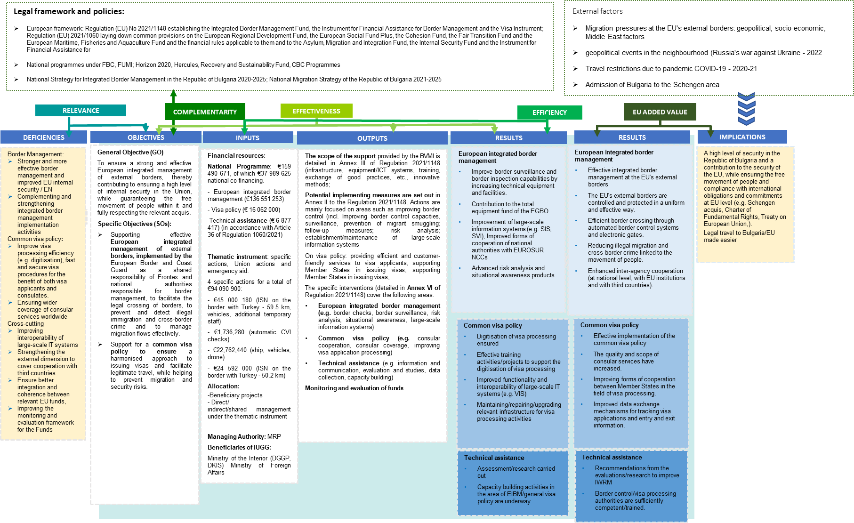

## Assessment methodology and limitations

### Summary of methods used

The methodological approach described below follows the sequential structure outlined in the ToR. An overview of our approach is presented in the graphic below.

Figure . General methodological approach

Interview questionnaires and survey

Task 3.3

Writing the final report

Task 3.2

Final analysis and triangulation

DATA COLLECTION

HOME

ANALYSIS AND REPORTING

Task 1.1

Start meeting

Task 1.2

Overview of information sources

Task 1.3

Overall development of the evaluation framework and methodological approach

Task 2.1

Documentary study

Task 2.3

Survey

Data collected for the evaluation

Task 3.1

Quantitative analysis

Final report

PRODUCTS



Task 2.2

Interviews

**TASKS**

**STAGES**

**The inception phase** allowed the team to further develop its understanding of the current legal and strategic framework and existing empirical evidence for the implementation of the Republic of Bulgaria's BMVI Programme 2021-2027. Based on this familiarisation, the data collection instruments (interview questionnaires, surveys) were developed to ensure the implementation of the next stage of service delivery.

**The data collection phase** of the mid-term evaluation included the following tasks:

* In-depth documentary research;
* Conducting 10 in-depth interviews with up to 20 officials of the State Border Police, the General Directorate of Border Police (including the management, representatives of the Border Surveillance and Border Control Departments, the Specialized Air Surveillance Unit, project coordinators, a representative of the Elhovo and Airports RDBP), and representatives of the Ministry of Foreign Affairs.
* A survey of **279** employees of the DGBP and all regional directorates (RDBP). (Annex 2).
* The final stage, **Analysis and Reporting,** analysed the available data to address the key evaluation questions and provide conclusions and recommendations for the remainder of the BMVI 2021-2027 implementation period. In answering the questions, the following analyses were also conducted:
* Analysis and assessment of the socio-economic environment and its impact on programme implementation
* Analysis and assessment of changes in development needs in terms of relevance to the needs of target groups identified in the programming process
* Analysis of the Union added value of the actions implemented under the Fund programme
* Analysis of the effectiveness of management and control systems.
* Analysis of coordination, coherence and complementarity between actions supported by the Fund programme and support provided by other Union funds.
* Analysis of the actions implemented with, in or in relation to third countries: 1 such project is foreseen within the IGMP programme - but not yet included in the annual programmes for 2023/2024 at this stage - and therefore not analysed.

The main limitations of the applied methodology are the following:

* **Lack of a starting point**: due to the lack of a final evaluation of the previous financial period (2014-2020), it was necessary to collect information on the implementation of the programme from the financial period 2014-2020 in the framework of the interviews and documentary review.
* **The short timeframe for the** evaluation (3 weeks) did not allow to go into much depth on the needs analysis. This was offset by good mobilization by the MA to provide information, distribute the surveys, and schedule the interviews.
* **Lack of sufficient progress in project implementation:** theevaluation of effectiveness was hampered by the early stage of programme implementation, the lack of indicators yet reported, or procurement carried out or implemented. The focus of stakeholder consultations was mainly on the needs and expectations for successful project implementation.

# Current status of the BMVI

## Procedural progress

|  |
| --- |
| Despite some delays in the approval of the BMVI Programme, with the announcement of calls and the approval of 21 projects to the DGBP and CISD in 2023, the procedural progress towards the beginning of 2024 can be described as satisfactory. |

Despite some delays in the development and approval of the BMVI Programme, with the launch of four calls for grant applications to specific beneficiaries and the conclusion of 21 agreements at the end of 2023 (31 by March 2024), procedural progress by early 2024 can be described as satisfactory.

Preparations for the adoption of the BMVI Programme began in 2019 (see Figure 2). This process started with the adoption of Decision No. 196 of the Council of Ministers of 2019 approving the analysis of the socio-economic development of Bulgaria 2007-2017 for the definition of national priorities for the period 2021-2027. According to Art. 3 (l), the Ministry of the Interior is designated as the lead agency for the development of the BMVI Programme for the period 2021-2027. The Council for Coordination in the Management of European Union Funds is entrusted with the discussion of the priorities to be financed during the programming period 2021-2027 in Bulgaria, including BMVI, by the Decision No. 142 of Council of Ministers from June 2019 on the development of strategic and programming documents (art. 2.2). Article 7 of the same PPA establishes thematic working groups for the development of the BMVI Programme. Article 7 also identifies a wide range of stakeholders who should be members of the thematic working groups, which include not only internal security stakeholders, but also cross-cutting human rights priorities, trade unions, employers, local government, the non-governmental sector, as well as state institutions responsible at central level for managing EU funds.

The Thematic Working Group was established by order of the Minister of the Interior in December 2019 and has started active work on the development of the 2020 programme, using as a basis the programme document received from the European Commission with priority topics to be included in Bulgaria's programme. The working group is headed by a line deputy. The secretariat is the International Projects Directorate and the members are the DGBP, CISD, and the Ministry of Foreign Affairs, but representatives of other stakeholders are also involved: General Directorate of National Police, Directorate of International Operational Cooperation-MIA; National Institute of Forensic Science-MIA; Directorate of Bulgarian Identity Documents-MoI; Directorate of European Union and International Cooperation-MoI; Academy of the Ministry of Interior; Council of Ministers; Managing Authority of Operational Programme Good Governance; Customs Agency; National Commission for Combating Human Trafficking; University of National and World Economy.

By the end of the year, an informal draft of the programme was discussed and sent to the European Commission, and 2021 began with a discussion of the comments received from the European Commission. Discussions on the informal versions of the programme, the EC's comments on them and the indicative allocation of funds for the programme continued until October 2021. In October 2021, following a public consultation and agreement in the EU Funds Coordination and Management Board, the first formal draft of the BMVI Programme was approved by Decree No 718 of the Council of Ministers and sent to the European Commission in accordance with Regulation (EU) 2021/1060. In December 2021, a draft of the Programme was sent to the European Commission reflecting the European Commission's comments and the thematic working group (TWG) approved a list of priorities and measures to be supported under the Republic of Bulgaria's programme under the Fund. By November 2022, the negotiation process of the Republic of Bulgaria's programme under the Fund with the European Commission was actively continued, and a final version of the BMVI programme was approved on 7 November.

In the meantime, in January 2023, a Monitoring Committee for the Internal Security Fund programmes and the Instrument for Financial Support for Border Management and Visa Policy 2021-2027 was set up by order of the Minister of the Interior, in implementation of the Decision No 302 of the Council of Ministers. Pursuant to the PM No 302, the range of organisations nominating members to the Monitoring Committee has been expanded to include, similar to the TWG, NGOs and international organisations, representatives of social and economic partners (trade unions and employers' organisations), representatives of regional and local authorities, organisations of disadvantaged people, representatives of the academic community. In 2023, the Monitoring Committee was able to adopt the internal rules of procedure, the Indicative Annual Work Programme for 2023, the methodology and criteria for the evaluation of project proposals, the programme evaluation plan, the communication strategy, at meetings of the Monitoring Committee and through written non-presidential decision-making procedures.

Figure . Procedural progress of the BMVI - 2019 - 2023

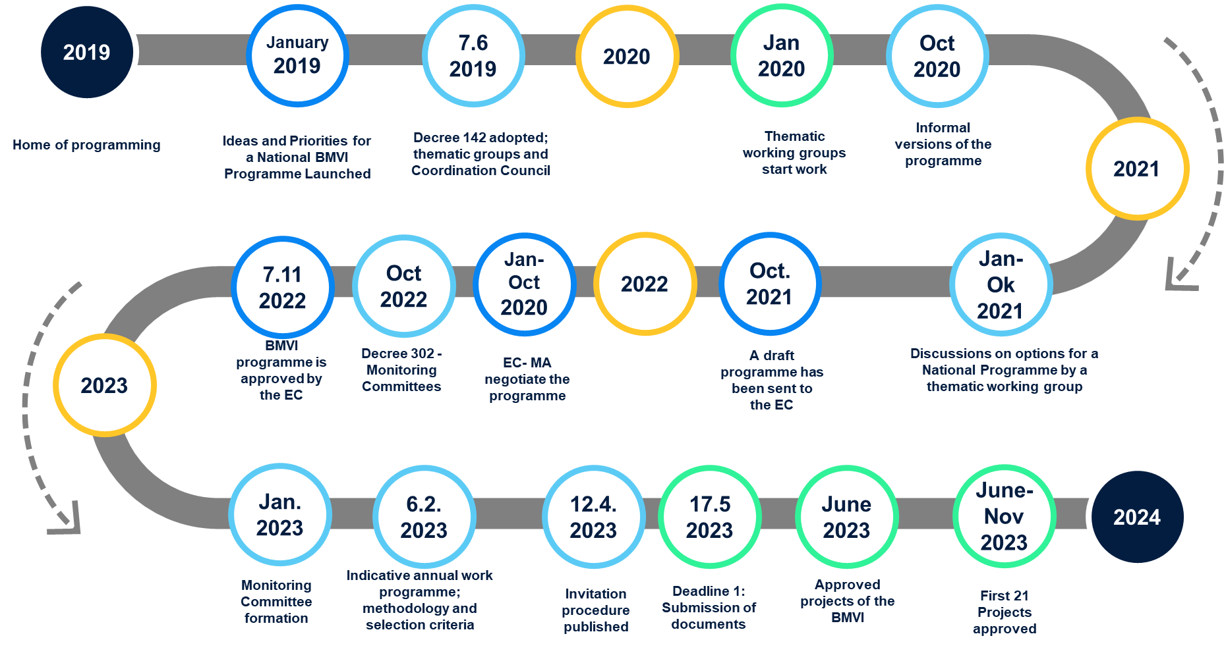

The indicative annual programme for 2023 foresees 4 procedures with 31 operations (see below), which are being implemented and agreements are being concluded for all operations. In January 2024, the Monitoring Committee approves and the indicative annual programme for 2024 plans 5 procedures and 19 operations. (These fall outside the scope of this report).

## Financial progress

### Programmed expenditure

The approved 2021-2027 **Programme** under the BMVI is worth a total of €121,501,047 (€159,490,672 with national co-financing). Within the programme, the funds are split:

* Priority 1 (CCS) - €136 551 253 (incl. national funding)
* Priority 2 - Visa Policy - €16 062 000 (incl. national funding)
* Technical assistance - € 6 877 417

Funding from 4 **specific actions** totalling €94,090,900 (excluding national funding and totalling €107,175,899 with national funding) has been added to the programme in 2023. These include (without national funding):

* €45 000 180 (ISS on the border with Türkiye - 59.5 km, vehicles, additional temporary staff) (BMVI/2023/SA/1.1.2/002)
* €24,592,000 (50.2 km ISS on the border with Türkiye) (BMVI/2023/SA/1.1.4/06)
* €22 762 440 (ship, vehicles, drone) (BMVI/2023-2024/SA/1.2.2/07)
* €1,736,280 (automatic CVI checks) (BMVI/2023/SA/1.1.3/004)

After adding to the Programme the funding of the specific actions, the total cost of the Programme reaches **€215 591 947** of European co-financing or with national funds - a total of **€266 666 571**. Of these additional funds, €5,325,900 are for additional technical assistance, bringing the total amount of technical assistance to €12,203,318.

EU co-financing varies, and for most activities is 75%, except for technical assistance where it is 100%, and for specific actions[15] it is 90%.

Figure . Resources in the BMVI Programme

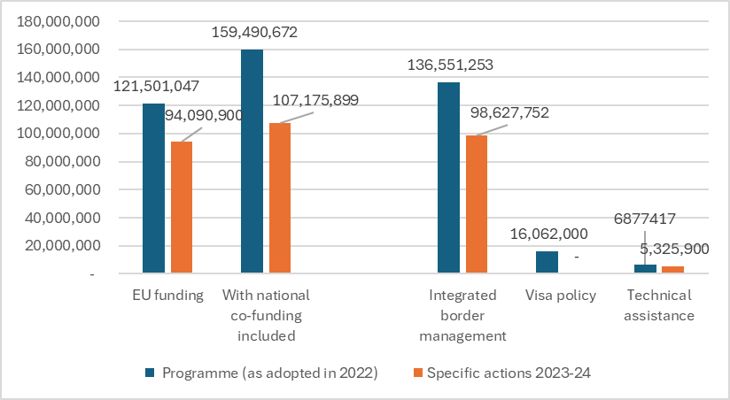

Source: based on data from the BMVI Programme / specific actions

### Thematic distribution of programmed expenditure

The 2021-2027 BMVIM Programme covers 29 intervention areas under SO 1 and 12 under SO 2 (according to Article 13(18) of the BMVIM Regulation). With regard to SO1, there is funding foreseen in 14 of the 29 areas In the originally approved programme, the most significant share of the 37% programme is allocated to land and sea related equipment (interventions 003, 004) as well as other measures (006) for border surveillance. Operational support is the second largest: 33%, according to Regulation 1148/2021. At present, the total operational support foreseen under both objectives is worth 38 625 750 euro. The largest part of this, € 35.02 million, is for SO1, and for SO2, € 3.6 million. As the funds are added to the specific actions, the amounts for the different priority areas increase and change. For example, the total expenditure on border surveillance reaches 72% of the total funds in the IBMD programme.

Figure . Programme of BMVI by type of intervention (IBM)

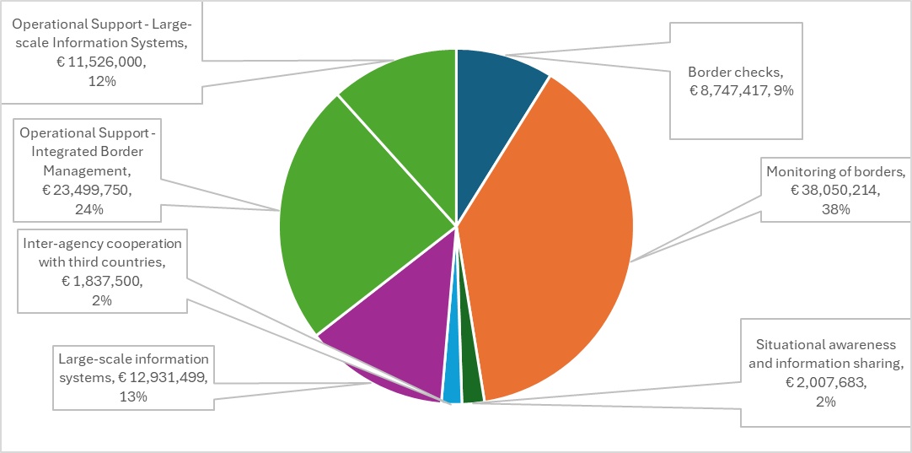

Source: elaborated on the basis of the data from the BMVI Programme (without specific actions)

With regard to visa policy, out of 12 possible areas of intervention, expenditure is foreseen for 5 areas (Figure 11). The breakdown by category of interventions corresponds to the one originally adopted in the programme as there is no additional funding through specific actions.

Figure . BMVI programme by type of intervention (visa policy)

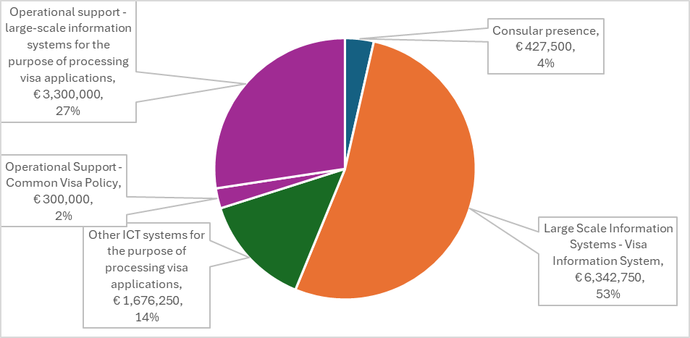

Source: based on data from the BMVI Programme.

### Progress on procedures

With the adoption in February 2023 of the Indicative Annual Work Programme of the BMVI for 2023, four procedures (calls for projects) were planned and subsequently launched, for a total amount of €108 689 819 (see Table 1), which foresee 31 projects (operations). As of 12.31.2023, Procedure 1 has been fully completed (with 21 operations) by the end of 2023 and the financing agreements have been signed. Procedures 2, 3 and 4 were completed while this study was being conducted and ended on 7.3.2024.

Table . Procedures completed and launched by the IPD

| Specific objective | European integrated border management | | | | Common visa policy | | |
| --- | --- | --- | --- | --- | --- | --- | --- |
| Procedures/value | Number of operations | Objectives of the operation | Benefi-  Cite | Number | | Objectives of the operation | Benefi-Cient |
| Procedure 1  €93 090 069 | 18  3 | Border control equipment (ships and vehicles) / maintenance of ISS and ASN | DGBP  CISD | 0 | | - | - |
| Procedure 2  €10 091 750 | 3  1  1 | Equipment for Border Control;  Annual fees for the ICAO-PKD system  Software support | DGBP  DBDS  CISD | 0 | | - | - |
| Procedure 3  €6 635 000 | 0 | - | - | 2 | | Communication systems NVC / maintenance NVIS | Ministry of Foreign Affairs |
| Procedure 4  € 72 850 000 | 3 | Specific actions of the EAGGF | DGBP | 0 | | - | - |
| Total  € 181 539 819 | **29** |  |  | **2** | |  |  |

Source: Indicative Annual Work Programme 2023 BMVI

## Physical progress

Physical progress, in terms of preparation of public procurement calls, at the time of writing is substantial, given the short time that has elapsed since the actual approval of project proposals after May 2023.

Under Specific Objective 1, BMVI, the actual disbursements resulting from contracts concluded or reimbursements for expenditure incurred totalled BGN 8,087,772.62.

Under Specific Objective 2, **visa policy,** projects have only been approved in early 2024 (for a total value of BGN 27 751 140), and therefore no amounts have actually been disbursed as of the date of this analysis.

The projects fall into four categories according to their stage of progress:

* **Completed projects**: operating costs for fuels that are paid either in full up front or after actual payments have been made (as is the case for fuel costs).
* **Projects for which contracts have already been signed** and advance payments of 20% have been made and are in the implementation stage. These are the projects of the Communications and Information Systems Directorate (CISD) for the Entry Exit System (EES) implementation or for the SIS maintenance; (in dark green in the table below)
* **Projects that have already been successfully procured** but contracts are still to come - the most significant of these is the DGPB contract for the purchase of patrol vehicles at a cost of BNG 69,205,983. This contract alone will affect the overall uptake level as it represents 32% of the annual programme and 22% of the approved 2022 BMVI programme.
* **Projects for which framework agreements have been concluded** with suppliers, but specific contracts are still to be signed (because, for example, a contract is still currently in force under ISF-Borders (2014-2020) or -- such are the **contracts for the maintenance of** the integrated surveillance systems (ISS), of the airborne/patrol vessels) (in light green in the table).
* **Projects that are still at different early stages of preparation of the procurement** (this includes those that have been tendered but are still under court appeal procedure) (in orange in the table).

In the table below, these categories of orders are marked with different colours (in green for held and

The main reason for the observed progress is due to the fact that, under the **Integrated Border Management priority**, work on part of the procurement started 'on condition' as early as 2023. Others fall under existing framework support contracts and others relate to operational costs for secondment of staff.

Table . Stage of Implementation of BMVI Projects

| **Project name** | **Home / Continued (months)** | **Total value (BGN)** | **Amounts actually paid (BGN)** | **Total order**  **Status** |
| --- | --- | --- | --- | --- |
| Large-scale information systems (LIS) | | | | |
| Development of an Entry/Exit System at land, river and sea BCPs at the EU external borders | 26/06/2023  (48 months) | 23,483,289 | 1,086,419 | Court Appeal of one of the lots; contract under another lot signed |
| Post-warranty maintenance of software and technical means for the purposes of N.SIS | 26/06/2023  (75 months) | 9,647,961 | 1,290,030 | Contract Concluded |
| Reliable and uninterrupted operation of national AIS components exchanging data with EU ICs | 26/06/2023  (75 months) | 5,867,400 | 1,041,698 | Contract concluded |
| Integrated Border Management (IBM) | | | | |
| Maintenance and repair of the ISS along the border with Türkiye from BCP K. Andreevo to BCP Lesovo | 19/09/2023  (40 months) | 9,415,221 | 0.00 | A framework maintenance contract already exists; |
| Maintenance of the ABC gates of the DGGP Airports built under DGGP projects | 19/09/2023  (42 months) | 1,972,864 | 0.00 | Potential change of project; |
| Fuel for marine and aviation equipment for a period of 3 years. | 19/09/2023  (36 months) | 5,261,102 | 210,444.00 | Stock exchange contract |
| Supply of vehicles for border control purposes | 19/09/2023  (60 months) | 69,205,983 | 0.00 | Completed procurement procedure  /contract in signature procedure |
| Maintenance and repair of the ISS on the Bulgarian-Turkish border from BCP-Lesovo to the Rezovska River | 19/09/2023  (40 months) | 6,199,886 | 0.00 | There is a framework agreement for 4 years |
| Maintenance of the third part of the Integrated Surveillance System at the border with Türkiye | 19/09/2023  (40 months) | 4,327,813 | 0.00 | There is a Framework Agreement Contract forthcoming |
| Maintenance and repair of perimeter surveillance and monitoring systems | 19/09/2023  (40 months) | 293,370 | 0.00 | Existing contract in force /new contract to be signed |
| Maintenance and repair of technical means for border control | 19/09/2023  (48 months) | 3,745,728 | 0.00 | Several procurement procedures are in the pipeline, 2 already contracted. (stationary post) advance payment pending |
| Supply of mobile surveillance systems | 19/09/2023  (21 months) | 10,561,320 | 0.00 | Preparation of the public procurement |
| Aircraft and personnel insurance | 19/09/2023  (76 months) | 1,955,800 | 0.00 | General insurance procedure of the Ministry of the Interior |
| Maintenance and repair of automotive equipment for a period of 3 years. | 19/09/2023  (40 months) | 4,498,340 | 0.00 | Existing contract expires in April; Preparation for new public procurement ongoing |
| Supply of handheld thermal imaging cameras | 19/09/2023  (20 months) | 5,339,334 | 0.00 | Preparing for the public procurement |
| Maintenance and repair of the built automated surveillance systems (ASS) in the area of responsibility of the Kalotina border section | 19/09/2023  (45 months) | 469,392 | 0.00 | Framework agreement concluded, contract to be signed |
| Maintenance of the established ASS in the area of responsibility of the Bregovo border section | 19/09/2023  (21 months) | 586,740 | 0.00 | By April in guarantee; Preparation for framework agreement/contract |
| Maintenance and repair of the Blue Border ISS for the period 2023-2025. | 19/09/2023  (34 months) | 7,613,929 | 0.00 | Framework Agreement until 2025; Contract forthcoming |
| Maintenance and repair of ship equipment for the period 2023-2025. | 19/09/2023  (34 months) | 3,911,600 | 0.00 | ISF-Borders contract still under implementation; framework procedure to be launched |
| Maintenance and repair of helicopters for a period of 2 years. | 19/09/2023  (30 months) | 3,911,600 | 0.00 | Three framework agreements and existing contracts at different stages |
| Supply of border police vessels and fast craft | 19/09/2023  (60 months) | 3,796,882 | 0.00 | Preparation of the public procurement |
| Maintenance of nuclear and radiological material detection systems and equipment | 17/11/2023  (40 months) | 1,122,140 | 0.00 | Contract concluded; advance payment forthcoming |
| Hiring additional, temporary personnel to guard the state border | 18/01/2024  (6 months) | 2,459,526 | 0.00 | 100% payment pending / procedure completed |
| Equipment for the national components of the European Border and Coastguard Agency under the EBCG | 23/02/2024  (34 months) | 46,206,458 | 0.00 | Preparing of the public procurement |
| ISS projects under specific actions | 23/02/2024  (48 months) | 92,255,086 | 0.00 | Preparing of the public procurement |
| Integrated solutions to facilitate and automate border crossings | 23/02/2024  (60 months) | 3,559,556 | 0.00 | Preparing of the public procurement |
| **Visa Policy (MFA)** |  |  |  |  |
| "Post-warranty maintenance and upgrade of the software components of NVIS" | 09/02/2024  72 | 19,137,835.73 | 0 | Framework Contracts |
| "Upgrading the connectivity between the Ministry of Foreign Affairs and Bulgaria's representations abroad" | 09/02/2024  72 | 8,613,304.61 | 0 | Preparing of the public procurement |

Source: MMIS[16]

# Evaluation findings

## Relevance

**Relevance** addresses the relationship between needs and problems in society and the goals of interventions, and touches on aspects of programming and design. As circumstances and contexts change over time, the needs and problems that the three funds address may change and new ones may arise.

### To what extent does the programme respond to evolving needs?

The BMVI responds to a large extent to the need for more effective border surveillance and control. The measures and priority envisaged are very much in line with both past and current needs.

**Specific Objective 1. Integrated border management**

Overall, the Programme in its part for Specific Objective 1 (SO1) - Integrated European Border Management meets both the needs that have been identified in the programming period (2020-2021) and at the current moment - i.e. the end of 2023. As shown in section 1.3 of this report, the period 2021-2023 sees increased pressure from unauthorised crossing of the EU external borders, both at BCPs and non-BCPs (at the "green border") on the territory of the Republic of Bulgaria. The measures planned under the BMVI for Bulgaria fully respond to the needs of improving the effectiveness of:

* Border surveillance
* Border checks
* The operation of the communication and information infrastructure.

***Border surveillance***

The statistics of the DGBP show that the pressure from unauthorized crossing of the external border of the Republic of Bulgaria is most significant **outside the** BCPs along the green border. The most important border section is the one with Türkiye (within the area of competence of the Regional BP Directorate Elhovo. Therefore, the most significant needs for adequate border surveillance systems and resources are needed in this part of the borders of the Republic of Bulgaria.

The concept of integrated management and surveillance of the border with Türkiye includes several components.

* Control of access through the border line by means of an engineering barrier (fence).
* An integrated surveillance system (ISS) covering:
  + Surveillance along the border and in depth on the territory of Türkiye through permanent observation posts;
  + Sensor lines along the border with Türkiye, which use different technologies and transmit a signal to a local/regional/national coordination centre;
  + Additional border surveillance approaches via mobile (e.g. thermal imaging cameras), mobile (perimeter surveillance systems), or portable (various equipment, including small thermal imaging cameras)
* Aerial surveillance by helicopters and drones.
* Foot and vehicle patrols by DGBP officers (with and without police powers) / Frontex officers who carry out surveillance and also implement measures to prevent illegal border crossings.

Figure . Total migration pressure to the Republic of Bulgaria (2023)

Source. DGBP

At the beginning of the programming period, the needs to ensure the most effective border surveillance are significant:[17]

* Nearly 1/3 of the border with Türkiye remains uncovered by sensor lines;
* The established sensor lines of the ISS sections 1 and 2 are outdated and inefficient, generating a large amount of false alarms and requiring additional staff to constantly monitor the information coming from the ISS.[18]
* The Blue Border ISS is now more than 10 years old and some of the radar devices produced by Bulgarian manufacturer[19] , will soon be unable to be maintained.
* As a result, migratory flows are being redirected to precisely these ISS-unprotected areas along the border.
* A large part of the off-road vehicles purchased with European funds are still new, but due to their intensive use and the poor condition of the roads in the border surveillance zone, the expected period in which they can be used is 3-4 years (i.e. by 2023);
* Other types of border surveillance equipment such as fixed posts, thermals, or perimeter surveillance systems also require maintenance, replacement of coolers or batteries.
* The aircraft (helicopters) purchased with funds under various previous instruments, as well as the hangar building where they are maintained, require a variety of expenses to ensure their airworthiness - engine maintenance, special surveillance equipment, helicopter mechanics, and also significant fuel and insurance costs - these costs have for the most part been provided by ISF-Borders. [20]

These needs, at the time of planning of the Programme in 2020-2021, are covered by funds from the ISF- Borders (and in particular the additional funding allocated by the ISF Emergency Support Mechanism in the area of Internal Security for € 118 420 257[21] ).

At the time of the initial planning of the BMVI Program, the program failed to provide sufficient funding for some of the most critical priorities - namely, completing the Integrated Surveillance System (ISS) at the Green Border. The Programme initially only provided funds for the maintenance of the already established ISS. However, through specific actions BMVI/2023/SA/1.1.4/06 and BMVI/2023/SA/1.1.2/002, additional funding is made available, which now allows for the complete construction of the ISS on the Bulgarian-Turkish border - these newly constructed sections will cover practically 100% of the needs for the functioning of the ISS.

Based on the identified needs, the MA and the DGBP have prioritized the implementation of measures related to the construction and maintenance of the ISS, as well as the purchase of vehicles (off-road).

The needs thus enumerated are also confirmed by the responses in the survey among DGBP officials, where on average 85% of respondents answered that the planned investments in border surveillance are needed to a great or very great extent. The most acute needs are maintenance for existing or new off-road vehicles and new uniform clothing. Regarding interventions for border surveillance equipment, on average 77% of respondents believe that the foreseen investments are needed to a great or very great extent. In addition to uniformed clothing, IT equipment and technical means for document verification were highlighted as the most acute needs. The full results of the survey are presented in Annex 2 of this report.

A substantial part of the changes in the Programme made through specific action BMVI/2023-2024/SA/1.2.2/07 are a consequence not only of national needs to develop the capacity for surveillance and control of the sea and land borders, but also of the priorities of the European Border and Coast Guard. In terms of national needs, the concept for the development of the "maritime" component of the integrated maritime border surveillance system foresees the gradual replacement of some of the oldest border patrol vessels, which were built more than 50 years ago (1969 and 1970) and which are scheduled to be phased out in the near future.

In addition to national needs, additional needs arise from the changes to the EBCG Regulation 2019/1896, the need on the one hand to strengthen the operational capacity of the Agency, in accordance with Article 64(14) of Regulation 2019/1896, and on the other hand to address migration flows to the European external maritime (mainly Greece and Italy) and land borders. The purchase of a border patrol vessel under the specific action, as well as the land patrol vehicles are aimed to achieve these objectives.

***Border control***

As noted in section 1.3 of the report, after 2022 and the end of the pandemic, there is a significant increase in BCP traffic and pressure from unauthorised crossings at BCPs. The busiest BCPs at external borders remain BCP Kalotina, BCP Kapitan Andreevo, and BCP Sofia Airport. The needs of the different borders are also determined by the specificities related to both facilitating legitimate traffic and preventing illegal migration. Several additional factors also determine the needs of BCPs[22] :

* The entry into force of the much-delayed EES (Regulation 2017/2226), which is expected to come into force in October 2025, is expected to be a significant challenge for infrastructure and passenger flow. While at the airports, the infrastructure and the passenger flows are easier to cope with the challenge of processing biometric data, significant challenges are expected at Kalotina BCP and Kapitan Andreevo BCP, especially during the summer months. The introduction of the Regulation will also require a changes in the infrastructure at all BCPs and the installation of larger booths at the first line checks allowing biometric data collection. The expected entry of the ETIAS - Regulation 2018/1240 will further complicate the processing of passenger flow.
* All of these new systems necessitate the development of both the physical infrastructure of BCPs and the communications and information infrastructure.

***Communication and Information Systems***

In addition to the above-mentioned needs related to BCPs and the development of the EES, ETIAS, a major challenge remains the maintenance and development of the Schengen Information System (SIS). The hardware infrastructure, as well as key components of the communication connectivity ensuring the security and reliability of the NIS and the connection to the SIS, has been built, upgraded and maintained over the last decade with EBF and ISF-Borders funds. The development of the SIS, the changes in the SIS Regulation (see 1.3) as well as its connectivity with other systems - EES, VIS, ETIAS, Eurodac, (as well as the interoperability between them), which are also evolving during the period of this evaluation, determine the need for a continuous and reliable maintenance and further upgrading and enhancement of its system operation and biometric data handling capacity. In this sense, the envisaged SIS maintenance and development projects will contribute to addressing these needs.

**Specific objective 2: Visa policy**

With regard to Specific Objective 2, the programme foresees the following activities:

* Improving the infrastructure of consular offices through the purchase of real estate (in Ankara (Türkiye), the construction of a new building (Beijing (China), or renovations to the conditions of existing consular offices (in Hanoi (Vietnam) and Istanbul (Türkiye).
* Upgrading communication connectivity and developing an integrated guaranteed communication link and alternative communication channels of the consular services with the National Visa Centre
* Upgrading of N.VIS software and hardware and introduction of electronic services

The maintenance of the applied software (standard licenses) and hardware and technical equipment for N.VIS as well as the repairs of the consular offices will be financed as operational support.

The analysis shows that the envisaged activities and their expected results continue to meet the needs and priorities of the visa policy development in Bulgaria.

The majority of the Bulgarian consular facilities need substantial investments to improve the conditions and to meet the needs and security requirements. At the time of writing, no analysis has been provided to show how some consular offices proposed in the programme are prioritised over others. Rather, the explanation received was that BMVI funds were focused where the needs required the most substantial investment.[23] The same needs are also highlighted in the BMVI Programme, where it is noted that consular officers should have a high level of internal and external security of buildings and premises to carry out their duties. [24]

In terms of communications connectivity, this need was identified as ongoing as equipment purchased in previous periods wears out and needs maintenance. In some countries where there are more serious risks to communications connectivity (e.g. due to political unrest or unreliable communications infrastructure, the poor quality of internet connectivity supplied or the limited ability to build secure VPN tunnels.), further construction or maintenance of already established communications infrastructure (e.g. satellite) is imperative. [25]

It is noted in the BMVI programme that the main equipment related to visa services was installed in consular offices in 2008-2010. The maintenance, replacement with newer equipment and further upgrading of technical equipment and software for the needs of the N.VIS is an ongoing priority. On the one hand, periodic upgrades of operating system versions, e-mail servers, connecting database management systems are necessary due to expiring licences or maintenance of old versions.

On the other hand, there is a constant need to develop the N.VIS in line with the changing requirements of the VIS, in relation to the development of EU policies and legislation on visa, security, and border policies (e.g. the introduction of the EES, ETIAS, etc.), as well as to ensure compliance with the requirements for interoperability and seamless connection of the N.VIS with the VIS.[26]

### To what extent can the programme adapt to changing needs?

The program is still in a very early stage and the need for changes (except those resulting from specific actions) has not materialized. However, frequent political changes as well as the forthcoming accession of Bulgaria to the Schengen area may lead to the need for changes. Although the Monitoring Committee adopts most of its decisions through written procedures, there are clear rules for programme changes.

The BMVI Monitoring Committee has met twice since its establishment. However, through 8 written procedures, it has been able to efficiently and without delay adopt important decisions on the update of the Programme (for specific actions), the adoption of the indicative annual programme for 2024, as well as the announcement and criteria and evaluation of the foreseen procedures. As a result, the first indicative annual for 2023 has been implemented, and 2024 has already been adopted.

Due to the early stage of the Programme and the small number of meetings attended, it is difficult to assess the extent to which new priorities and circumstances (such as Bulgaria's accession to Schengen) allow for discussion and changes. Any urgent needs for changes are rather first initiated and still discussed bilaterally by the stakeholders and the managing authority[27].

Between 2020 and 2023. Bulgaria is going through a prolonged period of political instability and change of multiple governments, and annual changes both in the political leadership of the Ministry of Interior and the Ministry of Foreign Affairs and in the professional leadership of the DGBP. Although there has been overall stability in priorities, it is natural that there are different visions of priorities or approaches to implementing some of the strategic priorities set out in the Integrated Border Management Strategy.

**Specific Objective 1. Integrated border management**

The consultation highlighted the need to potentially modify some of the already approved maintenance projects for some of the outdated systems (e.g. ISS 1 and 2 and the replacement of sensor lines with a new generation of video-based sensors), as well as the replacement of some of the outdated and less-than-effective automated air border control counters. [28]

Bulgaria's accession to Schengen on 31 March 2024 and the abolition of border controls at air and sea borders, and in the near future also at land borders, may also trigger the need for changes in some of the priorities. The expectation is that additional resources and a more comprehensive plan for the implementation of compensatory measures in the BCP area will be needed, as well as the reconstruction of the infrastructure of BCPs at air borders to adapt to the new conditions. Such compensatory measures, which will also require funding, are expected to include:

* + Additional control vehicles outside the BCP area
  + Equipment for mobile checks of documents or vehicles outside the BCP area (UV lamps, heart-beat detectors, CO2 analysers)
  + Training of ground staff (check-in agents) for document and visa checks.
  + Enhance trans-border cooperation through contact points at the borders with Greece/Romania and a trilateral cooperation centre at the Kapitan Andreevo BCP.
  + Additional resources and professional development for Investigation Department of the DGBP.

It is the expectation of the MA that at a later stage changes to the BMVI Programme may be required. In this sense, the guidelines and procedures submitted by the EC for the modification of the programme are expected to be implemented. [29]

Public procurement procedures in Bulgaria are not particularly flexible. At the same time, the experience built up over the previous two financial periods, market consultations, and the purchase of similar equipment in the previous financial period, reduce to some extent the need for changes when there is a clear concept and specifications for procurement.[30]

**Specific objective 2: Visa policy**

Regarding the needs assessment and possible changes in relation to the visa policy, the interview conducted with a representative of the Ministry of Foreign Affairs shows that since the elaboration of the programme the most serious challenge is related to Bulgaria's accession to Schengen.

With Bulgaria's accession to the Schengen area as of 31.3.2024, some of the needs will change and it is possible that either new priorities will emerge or the existing programmes and priorities will be reformulated. First of all, the connection to the VIS and the full access to the VIS has already made it necessary to prioritise the work of the National Visa Centre as a matter of urgency in order to be able to successfully prepare for the issuance of Schengen visas and the full integration of Bulgaria with the VIS. Also, the envisaged electronic services are expected to undergo a modification as part of the needs are expected to be met by the online visa application platform being developed by the European Agency for the Operational Management of Large-Scale Information Systems (euLISA) as part of the digitisation of the Schengen visa issuing procedure via the VIS.

At this stage, however, no changes are required to the programme or the priorities and projects set out therein. This is mainly due to the short timeframe in which the Schengen-related system integrations have to take place - by the end of March 2024.

In general, the programming and prioritisation processes are not considered flexible enough to meet the needs of the MFA. Examples were given with property purchase opportunities in third countries, where market conditions are often opportunistic and opportunities arise to purchase property where immediate action is required. In a multi-year process of planning and executing such activity quick action is very difficult.[31]

## Effectiveness

**Effectiveness** looks at how successful EU-funded actions have been in achieving or progressing towards the objectives set. The evaluation forms an opinion on the progress made so far and the role of the interventions in achieving the observed changes. The mid-term evaluation also analyses whether the objectives can still be achieved on time or with what delay.

### To what extent is the programme on track to achieve its objectives?

|  |
| --- |
| Although the physical progress of the programme is very limited in terms of actual implementation of the contracts, at the time of this evaluation, the number of procedures and agreements signed in beneficiaries, and the progress of DGBP in public procurement procedures indicate that the programme could be able to achieve the specific and operational objectives that have been set and that all indicators will be met. |

**Specific Objective. 1 Integrated border management**

As demonstrated in the evaluation of the progress of the programme implementation, (see Table 2. BMVI ), the overall pace of fund absorption is good, not very different from all other cohesion funds[32]. Although there are no specific indicator values reported yet, the expectations of the consulted stakeholders are that the final indicator targets will be achieved[33]. Therefore, it can be concluded that if the current pace of implementation of the measures/operations is maintained, Specific Objective 1 (Art. 3 of the BMVI Regulation) can be achieved. More specifically, progress can be reported on the implementation of the following measures (in accordance Annex II) that contribute to the achievement of SO1:

* **Improving border control** (Annex II(1a)) - operations for which framework contracts for ISS or helicopter maintenance have been concluded or for which successful procurement has already taken place and a contract is pending (procurement of all-terrain vehicles) will contribute to improving the effectiveness of border control as early as 2024.
* **The development of the European Border and Coast Guard** (Annex II(1b) - The only measure foreseen is the signed specific action **(**BMVI/2023-2024/SA/1.2.2/07) for the purchase of a border patrol vessel and in perspective will also contribute to the achievement of SO1 in its entirety.

The expected effectiveness of some of the measures foreseen in the specific action BMVI/2023-2024/SA/1.2.2/07 have also met with mixed opinions[34] .

The use of drones so far, (which have been purchased under the ISF-Borders and are foreseen within specific actions) has not yet proven its effectiveness in the conditions of the Bulgarian-Turkish border. According to some of the consulted stakeholders, the specificity of the terrain, (dense foliage during the summer period when migratory pressure is highest) makes them little effective in most of the border, except in the area around Svilengrad where there are no forests.

* **Strengthening inter-agency cooperation at national level between national authorities responsible for border control or tasks (**Annex II(1c) - no actions have been foreseen.
* **Ensuring the uniform application of the acquis relating to external borders (**Annex II(1d)) no actions have been foreseen**;**
* **Establishment, operation and maintenance of large-scale information systems under Union law in the area of border management, in particular SIS, ETIAS, VIS and Eurodac (**Annex II(1e)) - framework contracts concluded and early progress on contracts concluded indicate that these objectives will be achieved. Although there has been a delay on the EES project due to an appeal of one of the procurement contracts, the CISD has an alternative plan to have the country ready for full implementation of the EES Regulation by October 2024, and the implementation of the EES.
* **Increasing capacity to assist persons in distress at sea and support operations - (**Annex II(1f) **specific activity and support search and rescue operations (**Annex II(1g) BMVI/2023-2024/SA/1.2.2/07 will contribute to these objectives. Procurement preparations are still pending.

**Specific objective 2: Visa policy**

In terms of visa-related projects, the least progress has been made - firstly, because the agreements with the MFA were only signed in early 2024; secondly, because no formal procedures had been launched in the MFA at the time of this assessment.

In early 2024, agreements were approved and signed for 2 procedures:

* **Provision of post-warranty maintenance of the software and hardware of the NVIS**, including the application software components of the NVIS (central and local), as well as the national interface to the EU Visa Information System (EU VIS) in compliance with the interoperability requirements and ensuring the continuous connection of the NVIS with the EU VIS and the VIS Mail visa advisory network. In addition to maintenance, the activities will include specialised training of system administrators, training on the software products used in the NVIS, and training of trainers on the functionalities of the NVIS system.[35] For this project, some of the contracts to be concluded will be part of existing framework agreements, this will reduce the risk of delays.
* **Upgrading the communication** connectivity and providing alternative communication channels (by upgrading and modernizing the terrestrial and satellite communication system) between the National Visa Centre (NVC) at the Ministry of Foreign Affairs (MFA) and the overseas representations of the Republic of Bulgaria. In particular, the provision of satellite data transmission between the MFA's NCC and 9 consular offices (in addition to the equipment built in the previous period), as well as the establishment of connections in 3 more consular offices (not yet identified).

Regarding the purchase and construction of consular offices in Ankara, and Beijing respectively, indicative bids were collected years ago, but no formal procedures have been launched so far. The expectation is that the purchase and renovation projects will be completed on time. In contrast to the previous financial period, where 25 renovations were planned, which ultimately failed due to the high volume and delays and procedures, the approach has now changed and the focus will be on four consulates. The key risk that has been outlined relates to the increased costs of renovation and construction works compared to the original estimates, which may affect and reduce the originally planned volume of renovation works or the number of new buildings constructed or purchased.[36]

A significant risk in relation to the implementation of activities for the construction, repair and modernization of consular offices of Bulgaria in third countries is due to the restrictions from the public procurement legislation and by-laws, linked to the execution of public contracts in third countries. In order to overcome these difficulties, an amendment to the Public Procurement Act is planned, in the part concerning contracting authorities, such as Bulgaria’s foreign representations in third countries (under Art. 5, para. 2, item 15 of the Public Procurement Act). As the proposals for legal changes are yet to be adopted, these MFA actions will be implemented in 2025 or 2026.[37]

### To what extent is the monitoring and evaluation framework appropriate to inform progress towards programme objectives?

Due to lack of any indicators, it is early to assess the extent to which the monitoring and evaluation framework practically can effectively support the monitoring processes, and eventually the final evaluation.

The monitoring and evaluation framework for the EIPD programme follows rules included in Regulation 2021/1060 (Chapter 1 and 2 of Title IV) for generally applicable provisions and Regulation 2021/1148 (Section V and Annexes V and VIII). At the national level, the rules for monitoring and evaluation are laid down in the EU Funds Management Act, where the rules for payments, verification and reporting of expenditure are included in Section II, and in the Decree No. 302, where the functions of the Monitoring Committee with regard to monitoring and evaluation are described (see Section 3.2.3). In addition, the Monitoring Committee approved the evaluation plan for the BMVI programme in November 2023. In this programming period, the rules for monitoring and evaluation of the BMVI programme are for the first time aligned with those of the other Structural Funds. To some extent, this facilitates the MA and the Monitoring Committee as they fully apply the applicable national legislation related to the management of EU funds and can rely on the experience gained by other MAs on other programmes in this respect.

Within the Managing Authority, the Monitoring, Verification and Payment Unit is entrusted with the main responsibility for monitoring and evaluation of the programme and carries out technical and financial verification through administrative and on-the-spot checks. The MA is also tasked with recording and storing in electronic form the data for each operation required for monitoring, evaluation, financial management, verification and audit purposes in accordance with Annex VII of Council Regulation (EU) No 2021/1060 and ensuring the security, integrity and confidentiality of the data and user authentication. The MA shall organise a meeting with the EC at least twice during the programming period for the BMVI programme to review the quality of the implementation of the programme, follow up on the issues raised during the meeting and inform the EC of the measures taken within 3 months. By 15 February 2023 and by 15 February of each year thereafter up to and including 2031, the MA shall submit to the EC an annual report on the quality of implementation, in accordance with Article 41(7) of Regulation (EU) 2021/1060. The reporting period shall cover the last accounting year. The annual report on the quality of implementation shall be entered in the electronic data exchange system - SFC 2021. In this respect, the annual quality reports on the implementation of the BMVI programme for 2022 and 2023 have been submitted on time. Five times a year (31 January, 30 April, 31 July, 30 September and 30 November), the MA submits cumulative data on the BMVI programme to the EC in accordance with the template contained in Annex VII of Regulation 2021/1060, except for data on output and outcome indicators, which are sent twice each year (31 January and 31 July). For this purpose, the experts of the MA’s monitoring unit verify the completeness and correctness of the data entered in the Management and Monitoring Information System (MMIS) for the quality performance indicators/indicators collected as a result of the progress reported for the relevant period for each project financed under the programmes. The indicator values in the MMIS are reconciled for each individual project and information is generated at programme level. It is correlated with the actual financial information on implementation during the period concerned. On the basis of the data generated in the MMIS, the monitoring unit prepares the information according to the template to be sent to the EC.

The Management and Monitoring Information System (MMIS) for the European Shared Management Funds (ESMF) itself is maintained by the Central Coordination Unit and ensures the electronic exchange of information and documents between it, the ESMF management and control bodies and the applicants and beneficiaries of financial support. Pursuant to Article 21 of the ESFM Act, the Central Coordination Unit, the authorities for the management and control of the EUSF funds, the applicants and beneficiaries shall enter, collect and systemise correct and reliable information on the implementation, management, monitoring, evaluation and control activities of the programmes referred to in Article 3(2) and the projects according to their competence in the ESFM Management and Monitoring Information System (MMIS) and in compliance with the principles of reduction of administrative burden, effectiveness, efficiency and economy. During the interview, the MMU mentioned that the MMIS is very intuitive and easy to use, very well supported and innovations are constantly being made to facilitate the work of the MA and are successfully communicated. Beneficiaries also consider that the MMIS facilitates reporting on their projects, although due to internal rules on document flow in their institution the data entered in the MMIS has to be duplicated in written form.

Both the Managing Authority and the Beneficiaries consider that the overall indicators reflect the main achievements of the programme and are in line with the intervention logic of the BMVI programme. The early stage of implementation of the programme does not allow to assess how easy they are to report and to what extent they will support the evaluation of the impact of the Fund. Evidence that the indicators follow the intervention logic of the programme is that only two procedure-specific indicators are currently set under approved projects - Number of vehicles supported; Number of training camps and certified training of trainers. At the moment, beneficiaries do not face difficulties in setting targets for their interventions as they have experience in this respect from previous programming periods. Beneficiaries have also received sufficient guidance from the MA on the content and reporting of indicators.

### How was the involvement of relevant partners ensured at all stages of programming, implementation, monitoring and evaluation?

**Specific Objective. 1 Integrated border management**

The involvement of the partner countries is ensured by the formation of a Thematic Working Group for the development of the BMVI Programme 2021-2027.

The approval of the programme also establishes the Monitoring Committee.[38] Compared to the previous programming period and thanks to the application of the national provisions applicable to all programmes co-financed by EU funds under shared management in the Republic of Bulgaria, the membership of the Monitoring Committee has been extended.[39] Alongside stakeholders in the borders and visas sector, the Monitoring Committee includes representatives of the social and economic partners (trade unions and employers' organisations), representatives of regional and local authorities, organisations of disadvantaged people, representatives of academia and NGOs. Decree No 302 of the Council of Ministers also lays down the rules for the procedure for identifying representatives of the academic community to participate in the Monitoring Committee and for selecting non-profit public benefit entities, the main objective being to ensure equal access to the opportunity to participate in the Committee and to select the most appropriate representative. Article 12 of the Decree describes in detail all the duties of the Monitoring Committee, which include both important activities related to the implementation of the programme (methodology and criteria for selecting operations; agreeing the indicative annual work programmes, approving the evaluation plan) and the monitoring of the programme (examining implementation and monitoring progress in programme implementation, examining information on the conclusions and recommendations of the annual monitoring reports). In the period up to the end of 2023, the Monitoring Committee for the BMVI and ISF Programmes has held two meetings and taken decisions through five written procedures, thereby contributing significantly to the process of preparing for the start of programme implementation through the timely agreement and approval of the necessary documents.

The participation of the members of the Monitoring Committee and the rules for its work are laid down in the Internal Working Rules, which were approved at the very first meeting of the Committee. The Internal Rules clearly set out the functions of the Committee, its composition, the responsibilities of the Chair and members of the Committee and of the Secretariat, the requirements for its meetings and the rules for decision-making. A Code of Conduct is also included. Interviews with the Managing Authority and the beneficiaries who are part of the Monitoring Committee show that there are currently no serious shortcomings in the functioning of the Monitoring Committee for the AMIF and ISF programmes.[40]

**Specific objective 2: Visa policy**

In terms of visa policy, the thematic working groups as well as the ISF/BMVI Monitoring Committee involve almost all stakeholders, including the SANS (which has a role in dealing with a number of procedural issues with the visa process), and the DGBP (which has a role in visa enforcement and verification at BCPs, and whose staff carry out daily checks at the VIS). The only directorate with a bearing on the operation of visa policy that is not represented on the Monitoring Committee is the Migration Directorate, which, like SANS, is part of the (short-term) visa process.

In view of the above mentioned mechanisms, the mid-term evaluation did not identify any shortcomings in the respect of the partnership principle in the programming, implementation, monitoring and evaluation of the BMVI programme, as partners are actively involved already at the programming stage and their role is clearly defined in the national legislation and internal rules applied.

### To what extent does the programme respect or promote horizontal principles in its implementation?

The Managing Authority shall implement measures to ensure compliance with the horizontal principles set out in the Horizontal Regulation as well as in national legislation, including compliance with the EU Charter of Fundamental Rights in the implementation of the programme - Article 9(1). The application of the principles of equal opportunities, transparency and equal treatment shall be monitored by the Managing Authority at all stages of preparation, evaluation and implementation of operations selected for support.

The preparation and implementation of the procedures for the awarding of grants under the BMVI shall be carried out by the Managing Authority in accordance with criteria and a methodology for the selection of operations which are in conformity with the Charter of Fundamental Rights of the European Union. The Application Guidelines set out requirements for grant applicants to declare that the activities envisaged are in line with and contribute to the implementation of the horizontal policies as well as the implementation of the EU Charter of Fundamental Rights and the UN Convention on the Rights of Persons with Disabilities. At the appraisal stage of the project proposal, this compliance shall be verified by the Evaluation Committee and followed up by the Managing Authority staff at the implementation stage of the project proposal.

By signing the Application Form, beneficiaries and partners commit to respect the horizontal principles of Article 9 of Regulation (EU) 2021/1060. Any form of discrimination shall be avoided in the implementation of the project activities. All project activities shall be neutral with regard to the beneficiary's membership of any group, on any grounds whatsoever, and shall not impose any restrictions based on sex, race, nationality, ethnicity, citizenship, origin, religion or belief, education, opinion, political affiliation, personal or social status, disability, age, sexual orientation, marital status, property status or any other grounds established by law or international treaty to which Bulgaria is a party.

The beneficiaries try to apply the principle of gender equality in the formation of the teams involved in the implementation of the projects and the relatively good ratio of men and women in the internal security structures helps them.

In projects that provide for construction (e.g., MFA consulates), it is not yet clear whether additional energy efficiency measures or compliance with standards that reduce global carbon emissions beyond what is required in the legislation are considered.[41] . This is largely indicative of a lack of overall policies and procedures in both the Ministry of Interior and the Ministry of Foreign Affairs regarding green policies, rather than implying that the implementation of the programme is not aligned with the goal of promoting sustainable development.

The mid-term evaluation of the BMVI did not identify any major gaps or problems at this stage related to the implementation of the horizontal principles.

### How effective is the program in communicating and disseminating its capabilities as well as accomplishments?

The Managing Authority has developed a communication strategy with properly defined target groups. The strategy was approved by the Monitoring Committee by a non-consensual decision adopted by written procedure in July 2023.[42] The national communication strategy provides the methodological basis on which the MA for the BMVI organises its publicity, information and communication activities. It also includes a Handbook on the visualisation of EU support for the implementation of the 2021-2027 information and communication rules, which unifies the requirements for all beneficiaries. The institutional framework for the management of information and communication activities, the objectives and target groups of information and communication activities, and communication channels are also described in the Management and Control System.[43]

At the beginning of the new programming period, communication activities include the launch of calls for proposals, information days for beneficiaries and training for beneficiaries. The main communication objectives are to ensure the visibility, transparency and publicity of the activities, to reach the widest possible audience, and to raise awareness of current and potential stakeholders.

Dissemination activities reach the target audience and are carried out through an appropriate mix of communication channels, mainly publishing the information online, as well as organising information days. Up-to-date information is regularly published on the Managing Authority's website: [https://www.mvr.bg/IPD](https://www.mvr.bg/dmp) , where regulatory documents, guidelines for beneficiaries, information on information days and other useful information are systematically published. The European Structural and Investment Funds one-stop information portal: [www.eufunds.bg](http://www.eufunds.bg/) also promotes funding and transparency of the BMVI processes. The programme's Facebook page is also actively used: [https:](https://www.facebook.com/BGISF)//www.facebook.com/BGISF. It publishes information on the EU funding made available and the possibilities to apply.

Implemented the following communication activities[44] :

* 7 events (4 trainings and 3 info-days) have been organised in person and online (9 planned by 2029);
  + 2 trainings for beneficiaries under the Public Procurement Act with a total of 300 participants. The trainings covered aspects of the AMIF, ISF and the BMVI;
  + 2 trainings for beneficiaries, which are held after the signing of administrative contracts/orders. A total of 160 people took part in them
* 23 publications on website and social media (75 planned by 2029)
* 271 followers on the fund's Facebook page (150 pledged by 2029). The content has reached 10,500 people, and has been accessed by 1,100 people, 96 of whom have also clicked on various links to explore further.

For each of the projects approved under the programme, measures and a corresponding budget for communication activities have been set. The budget set in the approved interventions in this respect represents about 1% of the contracted funds.[45] The description of the communication activities in the approved projects shows that the funds are mainly aimed at the installation of signs or boards, the production of promotional materials, the holding of press conferences and other information events. [46]

It is not clear from the communication activities described for individual operations whether social media will be used to reach a wider audience. A review of the use of social media (mainly Facebook) to communicate the achievement activities of the fund shows that the information is mainly aimed at communicating the activities of the MA (which has added value mainly to the stakeholders of the MA). Opportunities to reach the general public through a wider range of social media (e.g. Instagram, X) used by different age categories about the achievements of individual operations have not been used.

## Efficiency

Efficiency looks at the relationship between the resources used for the intervention and the changes generated by the interventions. The mid-term evaluation will look at how the chosen approach to implementing the interventions has influenced the effects.

### To what extent does the programme support cost-effective measures?

The BMVI programme supports cost-effective measures to some extent. As a significant part of the operations are a continuation of those of the ISF-Borders, and there a follow-up evaluation has not yet been done - it is difficult to assess cost-efficiencies. However, in the many operations related to the maintenance of already constructed sections of the ISS on the Bulgarian-Turkish border and the ASN on the Bulgarian-Serbian border, as well as the additional sections foreseen to be constructed under specific actions, mechanisms for achieving greater cost-efficiency should be sought. The long-standing practice of building different sections of the ISS with different technical solutions without a clear overall long-term concept is neither cost-effective nor operationally appropriate.

**Specific Objective. 1 Integrated border management**

A large part of the funds in the BMVI 2021-2027 programme are foreseen for the continuation of activities from the previous financial period. The lack of a ex-post evaluation of the ISF-Border makes it difficult to conclude whether these measures are efficient and cost-effective.

Examples are the measures foreseen for the maintenance of the first and second parts of the Integrated Surveillance System (ISS1 and ISS2), as well as the maintenance of automated border control counters at air borders. During the interviews it was expressed that the continued maintenance of these systems and equipment is not the most efficient possible solution for several reasons:

* The systems (ISS1/ISS2) are now close to or more than 10 years old, having reached the technical end of their life. Their maintenance has become increasingly expensive and difficult; (Similar concerns have been expressed about the Blue Border ISS). An example of expensive maintenance was given for ISS2 where seismic sensors that are buried in the ground, even if one is broken, stops an entire section from functioning and multiple sensors have to be searched for and dug up).
* The systems are outdated and far less efficient than new systems - basically giving multiple false alarms. This requires additional human resources to be mobilized to monitor the monitors where the signal is displayed in the LCC. Therefore, replacing the sensor lines with other forms of sensor lines (cameras with video analytics) will allow to free up human resources while increasing the efficiency of border surveillance.
* The presence of many different technologies used in ISS1, 2, 3 as well as those along the borders with Serbia implies different systems and companies to carry out their maintenance. Therefore, 5 different projects are foreseen in the current programme (3 for the maintenance of different sections of the ISS along the border with Türkiye and two for the ASS with Serbia). By using a single technology, all maintenance could be carried out by one supplier and one technology.
* The availability and maintenance of different types of sensor lines makes their integration into a single ISS difficult. An example was given, for ISS1, where the technology does not allow its integration with other systems. This further reduces efficiency (potential and effectiveness) as it requires multiple systems to be monitored.

With regard to the public procurement already foreseen and carried out, the approach adopted is cost-effective. There is no unnecessary fragmentation of procurement, insofar as it continues to maintain and invest in different ISS technologies.

**Specific objective 2: Visa policy**

Within the framework of the two approved projects under Specific Objective 2, multiple tender procedures are foreseen. Regarding the VIS maintenance project, 14 tender procedures are foreseen. At the time of the preparation of this report, 5 procedures have been successfully carried out, one procedure is at the stage of preparation and implementation, and the rest of the procedures are planned with a deadline of 2029 and will be implemented in stages.[47]

Within the foreseen activities of the Communication Connectivity Project, 6 tenders are foreseen. The procedures are divided in a way that distinguishes the different sub-activities in a logical way. The information at this stage is not sufficient to assess whether the envisaged tender procedures are divided as efficiently as possible, and whether there is a possibility of reducing their number if, for example, both actions cover all foreign representations, which would enable to combine in one procurement procedure the construction of an alternative radio- relay system for high-speed connection with upgrading and modernizing the communication connectivity between the Ministry of Foreign Affairs and its foreign missions.

### How effective is the management and control system?

The institutional system of governance and control is largely determined by the European and national legal framework. It guarantees the independence and objectivity of the individual processes. At this early stage, the management and control framework is practically only implemented in terms of choice of operations. The other aspects are based on European and national standards, practices and procedures, which largely ensure the effectiveness of the framework.

***Common framework for control***

The management and control system is largely determined by the European and national legal framework for the management of EU funds. The Decree No. 70 of 14.04.2010 entrusts the Deputy Prime Minister (presently the Minister of Finance) with the functions related to the management and control system of the AMIF, ISF and the BMVI, as s/he manages the overall organisation, coordination and control of the management system of the European Structural and Investment Funds. The control and management system is regulated by Decree No 712 of 6 October 2020 , which provides for:

* Managing Authority for the BMVI to be the International Projects Directorate (IPD) of the Ministry of Interior;
* Auditing Authority should be the Executive Agency "Audit of the European Union Funds" (EAAEUF);
* The functions of the Central Coordination Unit under Article 10 of the Law on the Management of the European Structural and Investment Funds shall be performed by the Directorate "Central Coordination Unit" in the administration of the Council of Ministers (subsequently moved to the Ministry of Finance).

Figure Governance structure for the 2021-2027 ISF, BMVI and FSMF programmes.

Minister for Finance

European Commission

Monitoring Committees AMIF and ISF/BMVI

Managing Authority: IPD at the MoI

Auditing authority: EAAEUF

Monitoring Committee central level

Central Coordination Unit: Ministry of Finance

Coordination Council

Financial Flows

Financial Reporting

**Source. MoI / DMP**

The management and control process of the AMIF, ISF and the BMVI also involves:

* Monitoring Committee for the Partnership Agreement of the Republic of Bulgaria;
* Coordination Council for the Management of European Union Funds for the Coordination of Measures for the Implementation of the State Policy for the Economic, Social and Territorial Development of the Country, Financed by the EUIF; (CUSEC) However, this Council has not met for 2 years[48] .
* A central coordinating unit is actively involved in all stages of preparation and programming of the BMVI.
* Audit Authority: is equidistant from all European funds and has the necessary administrative capacity and independence to be able to exercise real independent scrutiny of programme implementation. To date, no audits have yet been carried out on BMVI operations due to their early stage. This is a positive development following the European Court of Auditors finding of systemic errors in the operations of the previous Audit Authority (the Internal Audit Unit of the Ministry of Interior), which led to the imposition of a flat 10% financial adjustment on the ISF 2014-2020 programme for the financial years 2021 and 2022.

At the programme level, control is carried out by: (1) the ISF and BMVI Monitoring Committee, (2) the Audit Authority, and (3) the Managing Authority (MA).

MA activities are carried out in accordance with the rules and procedures laid down in Regulation (EU) 2021/1060 and the Financial Regulation, Decree No 23 of 13 February 2023 laying down detailed rules for the implementation of grants under programmes financed by the European Funds under shared management for the programming period 2021-2027.

In order to avoid conflicts of interest within the MA and to comply fully with the principles of sound financial management, the MA shall ensure the separation of functions through separate structural units and functional responsibilities:

* Programming of activities is carried out by the Programmes and Projects Unit, with separate teams with separate functional responsibilities for 'programming support' and 'project and procurement selection'.
* Preliminary Control and Irregularities" controls the award of grants according to the procedure described in Annex 3 of the Monitoring and Verification Procedures.
* Verification of expenditure on the awarded projects is carried out by the Monitoring, Verification and Payment Department, where the activities of "technical verification" and "financial verification and accounting" are carried out by separate teams. Verification of technical assistance expenditure including administrative and on-the-spot checks shall be carried out by a legal or natural person functionally independent of the MA

In addition, the principle of *segregation of duties* is applied so that one staff member is not responsible for more than one task - authorising, making payment or accounting for it - in the programmes' accounts. These activities must be carried out under the supervision of another MA staff member.

The following observations can be made with regard to the rules envisaged for the different MA functions:

* **Selection of operations**: the methodology for selecting operations has been approved by the Monitoring Committee. Sufficient procedures and guarantees for the objectivity of the process are included.
* **Verifications in the verification process** are based on a risk assessment and are proportionate to the risks identified in advance and in writing[49] .
* **The administrative checks** on payment applications shall also include ex-post control of the procedures for the designation of the contractor, the MA may at its discretion carry out a sample check of the documents before the announcement of the procedures for the designation of the contractor by the beneficiaries. The mandatory pre-selection criteria do not include the procedures referred to in Article 18(1)(a) of Regulation (EC) No 1605/2002. 1(13) of the Public Procurement Act (direct negotiation), but only points 8, 9 and 10.
* It is foreseen to hold regular project progress monitoring meetings in face-to-face or online format with the beneficiaries and to submit reports (Annex 8, Project Monitoring Procedure). It is not clear from the procedure when and at what stages these meetings take place.
* **The procedures for risk assessment as** well as detection of irregularities are defined by the EC.

.

**Administrative burden**

In the programming period 2021-2027, the applicable rules for the European Structural Funds under shared management apply for the first time to the BMVI Programme. At national level, this means that the regulations applicable to the management, implementation and monitoring of EU funds are fully applied. Although this framework includes some new administrative elements for the MA, to a greater extent the application of the generally applicable provisions has led to a facilitation of its work. The national regulatory framework applicable to the European Structural Funds has been developed on the basis of the long experience of several MAs in managing funds and the MA of the BMVI programme can rely on their extensive experience. A new feature for MAs will be the reporting of progress on the programme to the Central Coordination Unit, but in view of the frequency of reporting of this progress to the EC, this national obligation is unlikely to increase the administrative burden.

Based on their experience of applying for projects under the BMVI programme, beneficiaries consider the administrative burden to be comparable to that of the previous programming period and that of other financial instruments.

One of the problems identified that leads to unnecessary delay and repetition of procedures / administrative burden concerns the approval process for specific actions. This process in Bulgaria consists of two stages - the first is the EC approval process. This stage in itself takes about half a year from the announcement of the call by the EC, until the proposal is reviewed by the beneficiaries by the MA and until submission and approval by the EC. However, as the specific activity becomes part of the BMVI Programme, it is treated by Bulgaria’s Shared Management of EU Funds Act as part of the Programme. As specific actions are not foreseen in the other Structural Funds, the Shared Management of EU Funds Act also does not provide for an exception to the general rules for the next stage of the procedure. Instead of the beneficiary being able to use the funds immediately, the MA has to carry out the approval procedure again, and the multiple deadlines of the Shared Management of EU Funds Act that need to be respected take another six months. Thus, the whole process takes over one year and the two stages in practice overlap completely in its substance.

### To what extent is further simplification achievable and how?

Beneficiaries and MAs were unanimous that the MMIS significantly facilitates the exchange of information between them. It is a system that has been used for another programming period and to a large extent any problems related to its functioning have been eliminated.[50] In addition, the functionalities of the MMIS are constantly being improved and the MA and beneficiaries are always kept informed of these improvements.[51] The only problem mentioned by the beneficiaries is that the information they enter in the MMIS has to be duplicated in the internal document flow of their institution.[52] This is largely related to the internal rules of the beneficiary institution and not relevant to the requirements at EU level.

At this stage, no simplified cost options have been used under the BMVI. To a large extent, the internal regulations of the security sector departments are not adapted to the use of measures such as simplified cost options.[53] The internal rules on secondment of staff in the Ministry of Interior make it difficult to apply simplified cost options.

One of the problems in reporting operations that was noted was the need to complete a timesheet for time worked for participation in each project. This is not a problem in structures where there are fewer projects[54] . However, in structures such as the DGBP where there are over 20 operations (and with the prospect of becoming over 30 operations in 2024) some staff are involved in or coordinating multiple operations at the same time. As a result, they also have to fill in (manually) multiple timesheets in order to avoid double funding.[55] When individual staff members have to complete up to 10 different timesheets, both on paper (to be approved by their managers) and electronically in MMIS - this creates a significant administrative burden. This leaves opportunities to look for solutions to simplify reporting and reduce the administrative burden.

From the interviews conducted with beneficiaries, no problems with communication or exchange of information with the Managing Authority or other stakeholders involved in the reporting process of the operations were identified.

## Coherence and complementarity

The coherence assessment includes a review and analysis of how well the different activities and priorities of the national programmes are compatible and work together. The examination of internal coherence will include an examination of how the different components of the interventions work together to achieve the objectives of the programme, including coherence between measures and the specific objective, and between policy and specific objectives.

### To what extent is the programme aligned with the initiatives supported in its policy area, in particular with the support under thematic mechanisms in the different governance regimes?

The programme is substantially aligned with European and national border management and visa policies. The mechanisms for ensuring complementarity and coordination, notably the Monitoring Committee, the participation of the IPD in other Monitoring Committees, or the Central Coordination Unit, ensure to a large extent the coherence of the BMVI with all other European funds.

**Objective. 1 Integrated border management**

The BMVI programme and the operations implemented are substantially consistent with all presented in Part 1.3.3 European and national policies. The BMVI Programme corresponds to some extent with the *National Strategy for Integrated Border Management of Bulgaria (2020-2025) - NSIBM*. Most of the envisaged measures in the Programme are related to Strategic Objective 3 (Part 1.2 - Border surveillance), which foresees: "*Upgrading the available technical capabilities for border surveillance through the construction and maintenance of ISS, acquisition of new technical means, upgrading of existing equipment, as well as through further development of air surveillance capabilities using manned and unmanned aerial vehicles"*.[56]

As regards **border controls**, the operations foreseen in the programme correspond more to European priorities (implementation of the SIS Regulations, EES) than to the NSIBM. Long-term measures are not clearly formulated in the NSIBM. It relies on increasing staff and improving infrastructure (Strategic Objectives 1 and 2 Border checks 1.1). The most relevant, Strategic Objective 3, *Development, implementation and efficient use of technical solutions and systems to achieve reliable and efficient border controls*, is not further fleshed out. In the first two years, the primary focus of the NCISG Annual Implementation Plans[57] is *Modernizing the National Center to Combat Counterfeit and Forged Travel Documents*.

In the framework of cooperation with EBCGA and contribution to the European Border and Coast Guard Agency, the specific actions foreseen for the purchase of a border patrol vessel, vehicles and other equipment will contribute to the objectives of both Regulation 2019/1865 and Strategic Priority 4 (Cooperation between MS supported and coordinated by the European Border and Coast Guard Agency).

The BMVI programme does not cover some priorities and does not include operations that support all priorities of the National Strategy or the European Strategic Framework:

* Strategic Objective 1.3. Countering crime across the state border (where a potential target group would be the criminal investigation department of the DGBP;
* Risk Analysis (Strategic Priority 3);
* Technical and operational measures in the Schengen area (Strategic Priority 7)

**Specific objective 2: Visa policy**

The activities foreseen and projects already approved under SO2, Visa Policy, correspond and are in line with the development of the relevant European visa policy (presented under 1.3.4 of this report) , as well as with the national visa policy foreseen in the *National Migration Strategy of the Republic of Bulgaria 2021-2025* (which in turn is also in line with the EU visa policy).

The envisaged funding for the maintenance and development of the VIS responds to the many changes the VIS has undergone and continues to undergo with the changes in the Visa Code, as well as to the new regulations for developing interoperability between the EU information systems, VIS, ETIAS. These same priorities are highlighted in the *National Migration Strategy[58]* .

The BMVI Programme (2.1.1) also provides for operations to develop e-services. The strategy also highlights Bulgaria's support in the process of digitisation of the visa process[59] , which is also one of the main priorities in the European visa policy for 2025. [60]

### To what extent is the programme coherent with other EU funds (including other home affairs funds), in particular with EU external action?

The programme is substantially aligned with the programmes of other EU funds, including the Instrument for Pre-Accession Assistance cross-border cooperation programmes with Türkiye and North Macedonia. Due to the early stage of implementation of the programmes, the practical implementation of coherence mechanisms is difficult to assess.

**Specific Objective. 1 Integrated border management**

Firstly, the BMVI Programme is aligned with the implementation of the National **ISF-Borders** Programme (2014-2020), which had not been completed at the time of this evaluation. Contracts for operational support, equipment maintenance, or warranty periods for equipment delivered under the ISF-Borders were still being executed or in force. For example, the 12-month projects started in February 2023 for additional personnel and operating costs for operations funded under the ISF-Borders are expected to end in 2024. At the same time, DGBP approved operation*, Hiring Additional, Temporary Personnel to Secure the State Border*, is scheduled to begin after the one from the previous funding period ends, ensuring continuity of funding and operations. Similarly, the continuation of ISS, ship and aircraft maintenance is planned. [61]

In terms of **coherence with the AMIF (2021-2027) or the ISF (2021-2027)**, there are very few operations in the programmes where there are the same target groups. In general, the main beneficiaries under the three funds have clearly differentiated activities. With regard to the AMIF and the BMVI, no areas of overlap have been identified. In terms of coherence between the ISF and the BMVI, the possibility of coherence exists in the line of operations supporting investigations to prevent irregular migration.

Operational investigative activities, where the investigative activities of the DGBP on illegal migration may overlap with identical activities of the DGCOC (Combatting Organised Crime) and SANS. However, no operations are foreseen in the BMVI to assist the operational investigations (including risk analysis). On the other hand, the DGBP has not been involved with proposals for operations under the ISF, where the beneficiaries remain the DGCOC and SANS.

No **European funds or other funding sources** (e.g. Norwegian/Swiss Financial Mechanism) were identified in the interviews and document review that were not already taken into account by the Managing Authority. As all European funding programmes are at an early stage, no conclusions can yet be drawn on practical application or specific coordination steps in the preparation or implementation of operations. The Monitoring Committee for the ISF/BMVI also involves the other governmental institutions and Managing Authorities*[62]* , which have responsibility for European programmes with which there is a need for coherence. In particular, these programmes include:

* INTERREG VI-A Bulgaria-North Macedonia IPA 2021-2027 Programme, funded under the Instrument for Pre-Accession Assistance (IPA III). This programme foresees the construction of the BCP Strumyani – Berovo (with N. Macedonia). The technical equipment for border controls at the Strumjani BCP is planned to be financed by the BMVI.[63]
* The INTERREG VII-A Bulgaria-Türkiye IPA 2021-2027 (IPA III) programme foresees a pre-defined project of strategic importance related to strengthening the capacity of law enforcement institutions on both sides of the border to tackle irregular migration. The Programme notes that *the project is not sufficiently mature at the programme preparation stage, once the project parameters are available, a protocol will be signed between the managing authorities of Interreg VI-A IPA Bulgaria-Türkiye, BMVI and IPA III to establish clear reciprocities. and ensure no duplication*. [64]
* **Norwegian Mechanism:** programming and prioritisation activities are forthcoming. In the past, the Mechanism has financed compensatory measures at internal borders (e.g. the construction of TETRA at the Bulgarian-Greek border) or measures to counter corruption. It is envisaged to look again for complementarity.
* **The National Recovery and Sustainability Plan (NRSP),** one of the largest projects in the NRSP, envisages developing the TETRA system, both in its central and hinterland components, and developing the network and access to it in the hinterland. The system will be an enhancement to the existing TETRA system of the Ministry of Interior, which will improve law enforcement coordination of compensatory measures outside the 30 km zone along the external borders where the system is currently most developed.[65] .
* **Nationally funded projects:** the most significant nationally funded project envisaged is for a surveillance and identification system for drones along the border with Türkiye. This project is at a very early stage and it is not clear whether and to what extent it will be integrated into the ISS[66] .

**Specific objective 2: Visa policy**

As regards visa policy, the MFA is not a beneficiary of other funds. Potentially, the main opportunity for coordination is more in relation to the development of large-scale ICT systems (EES[67], SIS). No form of coherence is foreseen within the programming process or timeframes for the implementation of these projects by the respective directorate in the MFA and the Ministry of Interior (DCI). Rather, each of the respective SWI or VIS projects is focused on coherence with European timeframes and processes for commissioning these systems.

## EU Added Value

**EU added value** seeks changes that result from EU support, in addition to expected national actions. The added value of EU funding is analysed in terms of whether actions have been funded that would not otherwise have taken place, or would not have taken place on such a scale or in such a timely manner.

### To what extent does the programme generate EU added value?

The operations foreseen in the programme and already underway will contribute to improving the management of the EU's external borders and visa policy. Funding through the BMVI will enable additional border security measures to be financed which the Republic of Bulgaria would not finance on its own as a priority. Operations are also foreseen which will significantly increase the scale of such operations financed by the Bulgarian State, contributing to the achievement of SO1 and SO2.

**Specific Objective. 1 Integrated border management**

Protecting the external borders of the European Union is a shared responsibility of the Member States. The principles of solidarity are enshrined in the EU's legal and strategic framework. All activities aimed at securing the EU's external border therefore add value to the whole European Union.

Over the past decade, the construction and maintenance of an integrated surveillance system (ISS) at the border has been done solely with EU funds. The political decision not to invest national funds in the construction or maintenance of the ISS or in the purchase of air, land and sea vehicles is part of the understanding of shared responsibility for border surveillance. Bulgaria invests significant resources as a priority in many other aspects of EU external border surveillance, including:

* Funds for the overall maintenance of DG Border Police, mobilisation and training of staff;
* Funds for road maintenance along the border furrow and border security areas, including civil engineering;
* Compensatory measures in the interior of the country and at internal EU borders, including operational search activities;

Therefore, the funding provided through the BMVI for maintenance or investment in additional border surveillance and border control assets rather complements and enhances the capabilities and effectiveness of border management. Investments in the installation of ISS sensor lines in uncovered areas along the Bulgarian-Turkish border or the upgrading of existing sensor lines with new technologies, as well as investments in different types of new generation border surveillance equipment (e.g. mobile surveillance systems, night vision equipment) will **broaden the scope of** action in terms of investments in low priority or highly specialised areas. The objectives of the programme would be difficult for the Republic of Bulgaria to achieve without the funding provided by the BMVI. Investments in vehicles (including all-terrain vehicles), mobile surveillance systems, handheld thermal imaging cameras, and perimeter systems will help achieve **economies of** scale**. The** scale of investment would be far smaller in the absence of BMVI funding[68] .

Regarding investments in key systems necessary for the functioning of BCPs and law enforcement systems (SIS, Automated Information System for Wanted Persons), it can be concluded that their maintenance is also financed by national funds when necessary. However, as in previous financial periods, the BMVI will allow the systems to be maintained both in hardware and software terms in as good a condition as possible. The systems are thus far more efficient, as newer software and hardware equipment ensures a higher degree of availability and better performance[69] of the systems.

**Specific objective 2: Visa policy**

With regard to those funded under SO2, it can also be said that there is EU added value. Regarding the development of the infrastructure of the Bulgarian consulates in third countries - repairs are financed and carried out annually by the state budget. However, the renovations and purchases of buildings financed through the BMVI will enable a larger volume of necessary renovations to be carried out and more overseas representations to be covered that would otherwise not be covered (economies of scale). In the absence of the BMVI, the scope of repairs carried out or the number of buildings purchased by the Republic of Bulgaria would be smaller[70] .

Regarding the financing of the maintenance and development of the VIS, as well as of the communication infrastructure - over the years no interruption of their operation has been allowed, and even in the absence of European funds, the Bulgarian state will do what is necessary to have the necessary connectivity and support for the normal operation of the systems[71] . Since Bulgaria's accession to the EU with the purchase of equipment under the Schengen Instrument in the period 2007-2009, the financing of the maintenance and development of the NVIS has been done mainly with European funds, although until recently part of the maintenance was also carried out by the Ministry of Interior, but this has gradually been discontinued and the system has been developed and is now maintained by external suppliers.[72] As explained above in relation to SIS, the investment through the BMVI contributes to the systems being far more efficient, as newer software and hardware equipment ensures a higher degree of availability and better performance of the systems.

# Conclusions and recommendations

## Conclusions

### Current status and progress

Despite some delays in the approval of the BMVI Program, with the announcement of calls and the approval of 21 projects to the DGBP and DCIS in 2023, the procedural progress towards the beginning of 2024 can be described as satisfactory.

### Relevance

The BMVI responds to a large extent to the need for more effective border surveillance and control. The measures and priority envisaged are very much in line with both past and current needs.

The program is still in very early stages and the need for changes (except those resulting from specific actions) have not materialized. However, frequent political changes as well as the forthcoming accession of Bulgaria to the Schengen area may lead to the need for changes. Although the ISF-BMVI Monitoring Committee adopts most of its decisions through written procedures, there are clear rules for programme changes.

### Effectiveness

Although the physical progress of the programme is very limited, in terms of implementation of the projects, at the time of this evaluation, sufficient progress in the public procurement procedures, already underway, indicates that the programme will achieve the specific and operational objectives that have been set and that all indicators will be met.

Monitoring control systems, communication, are well prepared. In terms of communication and outreach to the general public, not enough effective activities are foreseen.

Involvement of relevant partners in all stages of programming, implementation, monitoring and evaluation envisaged. Horizontal principles at this early stage are foreseen, but their practical application may be difficult due to lack of experience.

### Efficiency

The BMVI programme supports cost-effective measures to some extent. In terms of programming processes, the most significant obstacle is the lack of adequate treatment of "specific actions" in the Shared Management of EU Funds Act. It treats them as an amendment to BMVI Programme and subjects them to the same project approval terms and procedures. This leads to a repetitiveness of some processes and to an unnecessary delay of about six months for the possibility of real use of the funds by the beneficiaries.

As a significant part of the operations are a continuation of those of the ISF-Borders, and no ex-post evaluation has yet been done there - it is difficult to assess cost-effectiveness. However, in the many operations related to the maintenance of already constructed sections of the ISS on the Bulgarian-Turkish border and the ASN on the Bulgarian-Serbian border, as well as the additional sections foreseen for construction under specific actions, mechanisms for achieving greater cost-effectiveness should be sought. The long-standing practice of building individual sections of the ISS with different technical solutions without a clear overall long-term concept is neither cost-effective nor operationally appropriate.

The institutional system of governance and control is largely determined by the European and national legal framework. It guarantees the independence and objectivity of the individual processes. At this early stage, the management and control framework is practically only implemented in terms of choice of operations. The other aspects are based on European and national standards, practices and procedures, which largely ensure the effectiveness of the framework.

### Coherence

The programme is substantially aligned with European and national border management and visa policies. The mechanisms for ensuring complementarity and coordination, notably the Monitoring Committee, the participation of the IPD in other Monitoring Committees, or the Central Coordination Unit, ensure to a large extent, the coherence of the BMVI with all other possible European funds.

The programme is substantially aligned with the programmes of other EU funds, including the Instrument for Pre-Accession Assistance cross-border cooperation programmes with Türkiye and North Macedonia. Due to the early stage of implementation of the programmes, the practical implementation of coherence mechanisms is difficult to assess.

### EU Added value

The operations foreseen in the programme and already under implementation will contribute to improving the management of the external borders and the EU visa policy. Funding through the BVMI will enable additional border security measures to be financed which the Republic of Bulgaria would not finance on its own as a priority. Operations are also foreseen which will significantly increase the scale of such operations financed by the Bulgarian State, contributing to the achievement of SO1 and SO2.

## References

The recommendations developed are intended to support the next stage of implementation of the BMVI Programme. The recommendations are directed both to the Managing Authority, the International Projects Directorate of the Ministry of Interior, but also to the beneficiaries/members of the Monitoring Committees that discuss and adopt changes to the National Programmes and other relevant legislation.

### Programming

**Inclusion of additional priorities:** In case of release of funds due to a change of the Programme or an increase of financial resources after the mid-term review, the possibility of funding operations that will address national or European strategic priorities not currently covered by operations may be considered. These could include:

* Countering crime across the state border / investigating illegal migration (where a potential target group would be the operational investigation departments of DGBP - Strategic Objective 1.3. This objective could potentially also be addressed by the ISF programme.
* Risk analysis (Strategic Priority 3): expanding the potential target groups beyond the DGBP, which could also include the DGCOC, SANS, Customs Agency, State Intelligence Agency, or the Military Information Service.
* Technical and operational measures in the Schengen area (Strategic Priority 7). In view of the abolition of border controls at internal air and sea borders, and in the near future also at the borders with Greece and Romania, operations focusing on compensatory measures could be supported.

**Maintenance and development of ISS**: it is necessary for the DGPC to adopt a plan, a concept, or even changes to the National Strategy for ISS, which will ensure sustainability in the development and investment in ISS, both along the Turkish border, but also along the external borders in general. In the implementation of the upcoming specific ISS expansion activities, technical specifications for ISS should be developed that avoid the risk of another disparate ISS phase. Such a document should set the direction towards a technically homogeneous ISS, which would allow both easier maintenance and integration and the creation, ultimately, of a single ISS. Such a document, or a revision of the Strategy, would help to ensure that the direction of ISS development is sustainable and less influenced by political changes.

**Reduction of approval timeframes for specific actions: approval** timeframes for specific actions currently take more than a year. These include repetition of the approval process - with the project being approved once by the EC, and again a second time by the MA. As specific actions are not foreseen in the other Structural Funds, the European Funds Management Act also does not provide for an exception to the general rules for approval of projects already approved under the specific action approval process. The IPD should propose the necessary legislative changes to the Shared Management of EU Funds Act to shorten the deadlines and avoid the need to re-approve projects of beneficiaries under specific actions already approved by the EC.

### Horizontal measures

**Developing the capacity to implement cross-cutting principles:** although the instructions and organisation to communicate cross-cutting principles (respect for human rights, respect for the interests of vulnerable groups, non-discrimination, decarbonisation), this may not be sufficient to implement these principles in practice. This is partly due to the lack of established practices along these lines in the MoI and other beneficiary institutions. To achieve better results, additional measures could include: (1) exchanging experiences with institutions or programme management bodies that have more substantial experience (e.g. Education or Human Resources Programmes); (2) practical training with external specialist speakers; (3) bringing in consultants to support these processes in developing procurement activities or specifications (e.g. for construction or renovation works).

### Monitoring and reporting

**Simplify the reporting process through** timesheets. The reporting process in MoI structures such as the DGBP, where there are more than 30 projects, creates an excessive administrative workload. One opportunity for simplification would be to adopt a single rate for project management and coordination. Another possibility to reduce the administrative burden on beneficiaries would be to use software solutions to complete timesheets, which are standard in the private sector.

### Communication strategy

**More targeted and extensive communication through social media: the planned** communication activities for the already approved operations are few and do not reach the general public sufficiently. Communication activities through social media (Facebook) are only carried out by the IPD, where the focus remains mostly on the IPD activities and not on the achievements of the individual projects that have been funded.

The BMVI funds are substantial and provide an opportunity for a better thought out social media communication strategy to reach the general public in Bulgaria. Considering the public and political importance of policies related to border security and migration, the messages that will reach the general public will have many positives:

* increased confidence in the Ministry of Interior and law enforcement agencies;
* increased trust in the EU and the principles of solidarity, the understanding that securing the external border is a common effort and responsibility;
* increased sense of security for citizens, understanding the investments being made.

Beneficiaries should be encouraged to invest in social media messages instead of different types of stationery, such as:

* Use the right forms of communication (purposefully developed videos) for key operations;
* Expand the range of communication channels used (besides Facebook, Instagram, X, Youtube, media partnerships);
* Target the messages to specific audiences (e.g. citizens in areas close to the border with Türkiye, or those whose social profile is "Eurosceptic").

### Control and management systems

Regarding the control and management systems, some possible improvements could be discussed, such as:

* In Annex 6: *Methodology for establishing criteria on the basis of which the Preliminary Control and Irregularities Department carries out preliminary control of public procurement and procedures carried out*, it is provided that the MA carries out preliminary control of procedures under Article 18, para. 8, 9 and 10 of the Public Procurement Act. Paragraph 13 of PPA (direct contracting) could also be added to the list.
* Clearer criteria could be set for when the regular project progress monitoring meetings are held - e.g. when there are certain milestones in implementation progress (Annex 8, Project Monitoring Procedure).

Annexes

1. Analytical framework

|  |  |
| --- | --- |
| **LINK** | |
| **Evaluation question** | **Indicative assessment criteria** |
| To what extent does the programme respond to evolving needs? | * The stakeholders of the programme are correctly identified in accordance with the objectives set out in the legal basis. * The needs analysis that led to the definition of the programme and the associated allocation of resources is consistent with the respective current and future needs of the relevant stakeholders. * The strategy developed to meet these needs, expressed in specific milestones and targets, aims to meet the most critical needs with proportionate resources. * The list of implementation measures included in the legal basis and planned under the programme is appropriate to meet the current and future needs of the target groups. * The work programme addresses the main priority needs and key target groups. |
| * To what extent can the programme adapt to changing needs? | * The needs assessment shall be carried out and updated regularly or as relevant contextual changes occur. * Monitoring Committee able to provide timely information on changing needs * There is a sufficient degree of flexibility in the design of interventions. * Where necessary, minor changes to the programme can be implemented quickly. * Policies and procedures are in place to ensure that significant program adjustments can be made in a timely manner if new needs arise. * If needs have changed since the adoption of the programme, programme interventions have been adapted in a timely manner or new needs have been adequately addressed through other instruments. * Procurement procedures ensure flexibility and bottom-up feedback. |
| **EFFICIENCY** | |
| * To what extent is the programme on track to achieve its objectives? | * Implementation has started with the operations selected for programme support under all relevant specific objectives and types of intervention, except where a delayed start is planned. * The early progress in achieving milestones and targets, taking into account the timing of programme adoption, is in line with expectations. * Challenges that affect performance and progress towards the Fund's objectives are properly identified and linked to effective remediation strategies. * The programme supports the types of interventions and types of actions known to be effective according to the available evidence * The Fund shall make use of available good practices where appropriate and possible. |
| * To what extent is the monitoring and evaluation framework appropriate to inform progress towards programme objectives? | * A robust electronic data exchange system is in place to record and store monitoring and evaluation data. * The data recorded in the system is reliable. * Monitoring requirements are properly understood by participants in the data submission process and training or information sessions are arranged as necessary. * Reporting on the outcome indicators correctly reflects the level of performance on the ground (no over- or under-reporting). * The common indicators reflect the main achievements of the programme in line with the intervention logic of the programme. * Programme-specific indicators are used to fill any significant gaps in the general indicators based on the intervention logic of the programme. * The comprehensive set of data recorded provides sufficient evidence to use as a basis for evaluating the impact of the funds, thus paving the way for subsequent evaluation. |
| * How was the involvement of relevant partners ensured at all stages of programming, implementation, monitoring and evaluation? | * There is a strategy to identify, inform and reach the most appropriate partners, which aims to ensure their balanced representation in the IPs. * Relevant partners are identified and involved at the programming stage. * The relevant partners shall participate in the ASC in accordance with their role as defined in the relevant rules of procedure. * Actions have been put in place to allow partners to be involved at all stages of the programme cycle. |
| * To what extent does the programme respect or promote horizontal principles in its implementation? | * Appropriate organisational and procedural measures are in place to ensure compliance with the EU Charter of Fundamental Rights in the implementation of the programme - Article 9(1). * Appropriate organisational and procedural measures are in place to ensure that appropriate steps are taken to take into account and promote gender equality and gender mainstreaming at all stages of the preparation, implementation, monitoring, reporting and evaluation of the Fund - Article 9(2) * Appropriate organisational and procedural arrangements are in place to enable appropriate steps to be taken to prevent discrimination on all grounds and at all stages of the programme cycle - Art. 9(3) * The Programme has appropriate mechanisms in place to ensure that implementation is consistent with the objective of promoting sustainable development as set out in Article 11 TFEU, taking into account the UN Sustainable Development Goals, the Paris Agreement and the principle of 'no significant harm' - Article 9(4). |
| * How effective is the program in communicating and disseminating its capabilities as well as accomplishments? | * A communication strategy is in place with properly defined target groups and appropriate monitoring measures, including appropriate and measurable targets for communication activities. * Dissemination activities reach the target audience and are carried out through an appropriate mix of communication channels and platforms, including social media, and generate interactions. * Funding opportunities are advertised appropriately and reach the identified target group of potential beneficiaries. |
| **EFFICIENCY** | |
| * To what extent does the programme support cost-effective measures? | * The Fund supports the types of interventions that are known to be cost-effective, based on available evidence. * Initial data from operations show that unit costs are in line with or below existing benchmarks and estimates. * Differences in unit costs between similar operations within the same programme can be explained and justified * For very specific, urgent or innovative actions, appropriate mechanisms exist to ensure that cost-effectiveness is considered as a criterion for beneficiary selection. |
| * How effective is the management and control system? | * The management and control system described in accordance with the legal basis is designed to ensure the effectiveness of the selection of operations, management tasks, the operation of the IP, the implementation of anti-fraud measures and procedures, the performance of the accounting function and the recording and storage of data for each operation. * The administrative burden is proportionate for all implementers (managing authorities, intermediate bodies) compared to the previous programming period/ similar services offered to comparable target groups without programme support. * The administrative burden is proportionate for all beneficiaries compared to the previous programming period/ similar services offered to comparable target groups without programme support. * The administrative burden is proportionate for all end-users, e.g. compared to the previous programming period/ similar services offered to comparable target groups without programme support. * Absence of 'gold-plating' at national level (e.g. by managing authorities, intermediate bodies, national audit authorities), i.e. requirements are not interpreted more restrictively than the legal basis or relevant documents providing methodological advice to Member States, unless there is good reason. * Absence of "gold plating" at EU level, i.e. requirements are not interpreted more restrictively than those in the legal basis and unless there is good reason. * The simplified cost options used lead to simplification on the ground. * Technical assistance shall be used to strengthen the command and control system where necessary. |
| * To what extent is further simplification achievable and how? | * There is evidence of legal requirements, procedural rules or practices that create a disproportionate administrative burden at EU or Member State level and there are concrete alternatives. * There is the option to additionally use simplified cost and financing options that are not linked to cost options. * There is evidence of a lack of coordination between the actors involved in the implementation of the Fund, leading, for example, to a lack of coherence, increased administrative burden, etc. * There are problems with electronic data interchange systems that cause delays and can and should be addressed. |
| **COHERENCE/COMPLIANCE** | |
| * To what extent is the programme aligned with the initiatives supported by its policy area, in particular with the support under thematic mechanism in different governance regimes? | * Structures, organisational arrangements or coordination mechanisms are in place to ensure coordination, complementarity and, where appropriate, synergies between different ways of managing the same programme. * Coordination mechanisms and arrangements are used regularly and to good effect. * The alleged overlap is in fact justified for objective reasons (e.g. same target group but different type of measure/different need being addressed/different readiness for the type of financial support chosen) * The programme is aligned with ongoing policy agendas at EU and national level. * There is evidence of inter-agency cooperation |
| * To what extent is the programme coherent with other EU funds (including other home affairs funds), in particular with EU external action? | * Structures, organisational arrangements or coordination mechanisms are in place to ensure coordination, complementarity and, where appropriate, synergies between other EU funds, in particular cohesion policy and EU external action. * Coordination mechanisms and arrangements are used regularly and to good effect. * The alleged overlap is in fact justified for objective reasons (e.g. same target group but different type of measure/different need being addressed/different readiness for the type of financial support chosen) * The programme offers support for cross-cutting policy programmes, complementing support offered by other EU funds. |
| ADDED VALUE FOR THE EU | |
| * To what extent does the programme generate EU added value? | * The Fund focuses on areas, interventions and target groups where results at EU level can go beyond what Member States can achieve acting alone. * There is evidence of reach effects, i.e. additional target groups or additional types of interventions. * There is evidence of economies of scale, i.e. greater volume of services/end users. * There is evidence of functional effects, i.e. training and increased capacity to manage the delivery of public support within the participating administrations. |

1. Survey of DGPC staff

The online survey was circulated by the DGPC management to all DGPC regional directorates with the request to reach rank and file employees. The survey was anonymous. The total number of respondents was 270 and the table below shows the number of respondents according to the structure in the DGPC.

Due to the relatively uneven number of respondents from some regional directorates, and the low number of respondents from the Elhovo, Airports, and Burgas Regional Border Police Departments, the survey does not have a good representation of the DGBP as a whole in terms of the structures that receive the most funds under the BMVI. The relatively high number of participants from the Smolyan Regional BP Directorate (covering the internal border with Greece), where the BMVI has a limited effect, explains why for most participants, BMVI / EU Funds is not so familiar yet. Responses are presented in absolute values and have not been weighted to seek statistical validity. For greater ease of visualisation, the answers for the needs questions 'to a large extent' and 'to a small extent' are presented in separate graphs.

Table . Number of respondents completing the survey

|  |  |
| --- | --- |
|  |  |
| Airports DGP | 1 |
| DGBP | 1 |
| Burgas Regional Directorate of Forestry | 6 |
| DGP Elhovo | 6 |
| WGDP Kyustendil | 8 |
| DGP Ruse | 38 |
| DGP Dragoman | 48 |
| RDHP Smolyan | 171 |
| Grand Total | **279** |

Figure . To what extent are you aware of the support that the DGCA is receiving under the 2021-2027 BMVI

N=279

Figure . To what extent do you agree with the following objectives of the BMVI?

Figure 16. Given your experience, to what extent in your work do you identify a need for the following support to increase the effectiveness of **border** surveillance

**N=279 (don't know/can't answer varies between 3 and 20 respondents)**

Figure 17. Given your experience, to what extent in your work do you identify a need for the following support to enhance the effectiveness of **border surveillance**

**N=279 (don't know/can't answer varies between 3 and 20 respondents)**

Figure . Given your experience, to what extent in your work do you identify a need for the following support to increase the effectiveness of **border control**

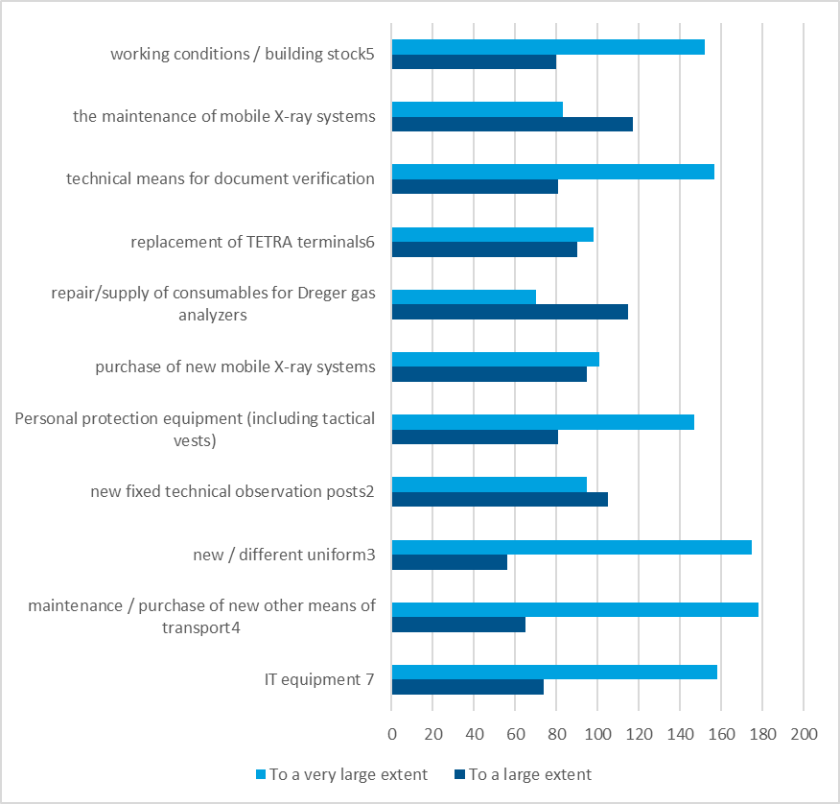

**N=279 (don't know/can't answer varies between 5 and 25 respondents)**

Figure . Given your experience, to what extent in your work do you identify a need for the following support to increase the effectiveness of **border control**

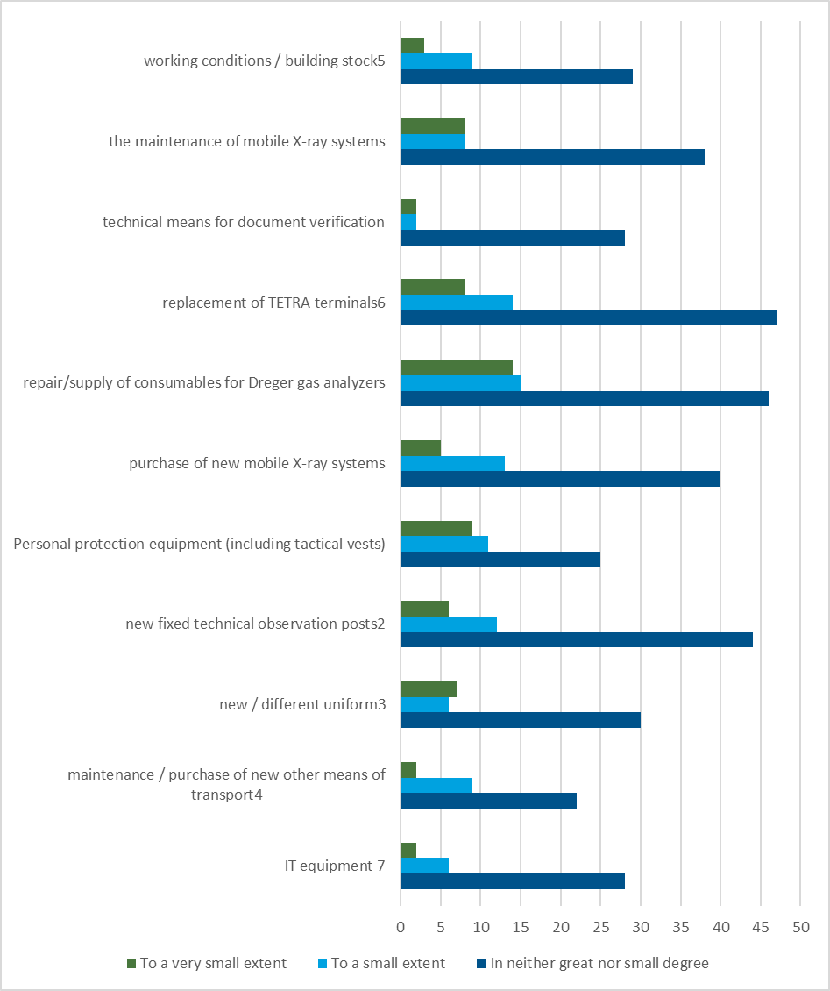

**N=279 (don't know/can't answer varies between 5 and 25 respondents)**

1. Interviews conducted

Table . In-depth interviews conducted

|  |  |  |  |  |
| --- | --- | --- | --- | --- |
| Code[73] | Position | Structure | Number of participants | Mode / Date of interview |
|  | OIGVP |  |  |  |
| 1 | Director / Deputy Director | DGBP | 2 | Face to face / 21.02.2024 |
| 2 | International projects | DGBP | 2 | Face to face / 21.02.2024 |
| 3 | Specialised Air Surveillance Unit | DGBP | 2 | Face to face / 22.02.2024 |
| 4 | DGFP - Elhovo - border surveillance | DGBP | 1 | Tel. / 22.02.2024 |
| 5 | Border Control Department | DGBP | 1 | Face to face /21.02.2024 |
| 6 | Border Surveillance Department | DGBP | 1 | Face to face /21.02.2024 |
| 7 | Airports DGP | DGBP | 1 | Face to face / 18.2. 2024 |
| 1 | Director / Project Coordinator | CISD | 2 | Online 22.02.2024 |
| 1 | Head of National Visa Centre | MFA | 1 | Face to face / 27.2. 2024 |
| 1 | Managing Authority PROGRAMMES AND PROJECTS DEPARTMENT | IPD | 4 | Online / 19.02. 2024 |
| 2 | Managing Authority - MONITORING, VERIFICATION AND PAYMENTS DEPARTMENT | IPD | 4 | Online / 19.02. 2024 |
| 1 | Central Coordination Unit | Ministry of Finance | 2 | Online / 27.2.2024 |
| Total |  |  | 27 |  |

1. See: https://commission.europa.eu/law/law-making-process/planning-and-proposing-law/better-regulation/better-regulation-guidelines-and-toolbox_en
2. See Eurostat statistics: [https://ec.europa.eu/eurostat/web/products-eurostat-news/w/ddn-20240208-1#:~:text=On%2031%20December%202023%2C%204.31,](https://ec.europa.eu/eurostat/web/products-eurostat-news/w/ddn-20240208-1#:~:text=On%2031%20December%202023%2C%204.31,protection%20status%20in%20the%20EU)protection%20status%20in%20the%20EU.
3. See: https://iacp-sofia.mvr.bg/press/актуална-информация/актуална-информация/новини/преглед/новини/служители-на-гдгп-са-предотвратили-близо-180-000-опита-на-мигранти-да-влязат-незаконно-в-българия
4. Outside the 30 km zone of competence to the DGBP.
5. Monthly Information on the Migration Situation in the Republic of Bulgaria for December 2023 available at: www.mvr.bg/docs/default-source/planiraneotchetnost/справка-декември-2023_internet.pdf?sfvrsn=432901b2_2
6. Statistics on short-stay visas issued by Schengen countries: [https:](https://home-affairs.ec.europa.eu/policies/schengen-borders-and-visa/visa-policy/statistics-short-stay-visas-issued-schengen-states_en)//home-affairs.ec.europa.eu/policies/schengen-borders-and-visa/visa-policy/statistics-short-stay-visas-issued-schengen-states_en
7. See: https://eur-lex.europa.eu/legal-content/BG/TXT/HTML/?uri=CELEX:52023DC0146
8. By Decision No 792 of the Council of Ministers of 30.10.2020.
9. See. https://ec.europa.eu/commission/presscorner/detail/en/ip_23_1629
10. Available at: https://eu-hr.mvr.bg/docs/librariesprovider79/документи/20rh792pr-1.pdf?sfvrsn=f3e0e681_2
11. See: https://home-affairs.ec.europa.eu/policies/migration-and-asylum/new-pact-migration-and-asylum_en
12. REGULATION OF THE EUROPEAN PARLIAMENT AND OF THE COUNCIL on the introduction of screening of third-country nationals at the external borders and amending Regulations (EC) No 767/2008, (EU) 2017/2226, (EU) 2018/1240 and (EU) 2019/817, available at: https://eur-lex.europa.eu/legal-content/BG/TXT/HTML/?uri=CELEX:52020PC0612
13. The regulations in the pact are expected to be finally adopted in April 2024.
14. See: https://eur-lex.europa.eu/legal-content/EN-BG/TXT/?from=EN&uri=LEGISSUM%3Al14517
15. The Programme originally foresaw only one of these, worth €11 091 254
16. Data available at: <https://2020.eufunds.bg/bg/8010828/0/OPProfile>
17. Interview DGBP2
18. The system, which over various financial periods has been built and maintained with funds from the ISF-Borders and the European Border Fund, as well as national funds. Stage 1 - from BCP Capitan Andreevo to BCP Lesovo (35 km, since 2012), Stage 2 from BCP Lesovo to BCP Malko Tarnovo (59.5 km, since 2015).
19. The manufacturer is in bankruptcy proceedings and it is unclear whether and for how long it will be able to maintain the installed radars (DGBP Interview 6).
20. Interview 3.
21. This is part of a total of €160 million (€178 million with national co-financing). See information provided by the Ministry of the Interior to the National Assembly: [https:](https://parliament.bg/pub/PK/257135754-06-41.pdf)//parliament.bg/pub/PK/257135754-06-41.pdf
22. DGBP Interview 5.
23. Foreign Ministry interview1.
24. IUGHR Programme, p. 23
25. Foreign Ministry interview1.
26. BMVI Programme, p. 22
27. Interview DGBP1, Interview IPD
28. DGBP interviews 1, 4, 6, 7.
29. Interview IPD 1
30. Interview MA1
31. Interview MFA
32. Interview MS
33. DGBP Interview 1, 2, 3, 4, 5, 6, 7.
34. Interview DGBP3 and DGBP4
35. See https://2020.eufunds.bg/bg/0/0/Project/Activities?contractId=j0rtGV6%2FFl0cr4AcxOad5g%3D%3D&isHistoric=False
36. Interview MFA1
37. Written comments provided by the MFA
38. According to the provision of Art. 302 of 29.09.2022 and by order of the Minister of the Interior
39. Decree of the Council of Ministers No. 302 of 29.09.2022
40. Interview IPD2, Interview DGBP2
41. Interview MFA
42. Minutes of the written procedure for non-consensual decision-making of the Monitoring Committee for the Internal Security Fund and the Instrument for Financial Support for Border Management and Visa Policy 2021-2027 programmes, held between 04.10.2023 and 11.10.2023.
43. Annex 14 of the Management and Control System of the AMIF, BMVI, ISF, 2021-2027.
44. Data provided by IPD
45. Summary of the EMIS data base
46. Summary of project proposals in EMIS
47. Written comments provided by MFA
48. Interview Ministry of Finance.
49. According to information from the MA, a risk analysis has already been developed in relation to the requirement to carry out so-called management verification in the sense of Article 74 of the Horizontal Regulation.
50. Interview Ministry of Finance
51. Interview IPD2
52. Interview DGBP2
53. Interview DGBP2, Interview Ministry of Finance
54. Interview with CISD, MFA.
55. Interview IPD
56. *National Strategy for Integrated Border Management in Bulgaria (2020-2025)*, p. 11, available at: [https:](https://eu-hr.mvr.bg/docs/librariesprovider79/документи/20rh792pr-1.pdf?sfvrsn=f3e0e681_2)//eu-hr.mvr.bg/docs/librariesprovider79/документи/20rh792pr-1.pdf?sfvrsn=f3e0e681_2
57. See. [https://eu-hr.](https://eu-hr.mvr.bg/docs/librariesprovider79/документи/планигу2023.pdf?sfvrsn=383675c6_3)mvr.bg/docs/librariesprovider79/документи/планигу2023.pdf?sfvrsn=383675c6_3
58. *National Migration Strategy of the Republic of Bulgaria 2021-2025, p. 25*, see https://eu-hr.mvr.bg/nsmgui/документи/национални-стратегии-и-планове
59. Ibid.
60. See: https://ec.europa.eu/commission/presscorner/detail/en/ip_22_2582
61. Interview DGBP 2
62. Ministry of Foreign Affairs, Council of Ministers (Central Coordination Unit, Good Governance Operational Programme), Ministry of Finance (Customs Agency). See page 7 of the Annual Report on the quality of the implementation of the EMAS referred to in Article 29 of Regulation (EU) 2021/1148
63. Interview DGBP 5
64. INTERREG Programme, p. 13 https://ipa-bgtr.mrrb.bg/sites/default/files/documents/2023-06/2021tc16ipcb005.pdf
65. Interview CISD.
66. Interview DGBP1
67. From a technical point of view, important changes to the VIS are also expected when the VIS is operational, such as the move to using a shared biometric matching system (sBMS). See page 5 of the euLISA 2021 VIS Report, https://www.eulisa.europa.eu/Publications/Reports/2021%20VIS%20Report.pdf
68. Interview DGBP 1, 6
69. That is, to minimize the periods when it stops functioning for technical reasons and, secondly, to return answers faster when making enquiries.
70. Interview MFA1
71. Interview MFA1
72. Interview MFA1
73. In the report, interviews are presented with codes that correspond to the structure where the interview was conducted and the interview number.